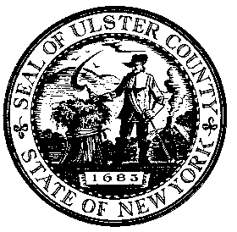 |  | Nomination Form  ULSTER COUNTY  OFFICE FOR THE AGING  1003 Development Court  Kingston, NY 12401 | Kelly McMullen, MA  Director
MICHAEL P. HEIN  County Executive |  | Ulster County Website: www.ulstercountyny.gov | Ph: 845-340-3456  Fax: 845-340-3583
Please use this form to nominate an Ulster County senior citizen who you think deserves to be recognized as the 2015 Senior Citizen of the year!

Unleash the Power of Age:
Recognizing Older New Yorkers Who Demonstrate the
Power of Making a Difference through Civic Engagement

Name of Nominee_____________________________________________________

Address of Nominee___________________________________________________

Phone Number of Nominee______________________________________________

Your name __________________________________________________________

Your phone number___________________________________________________

Tell us why you think the person you nominated deserves the award of Ulster County Senior of the Year. Include a brief history, any volunteer and community activities. Tell us a little about their career and family as well. You can add additional sheets as necessary. Other clippings are welcome but will not be returned.

Return this form with any additional information to the Ulster County Office for the Aging,
1003 Development Court, Kingston, NY 12401 or fax to 845-340-3583 by February 5, 2015

