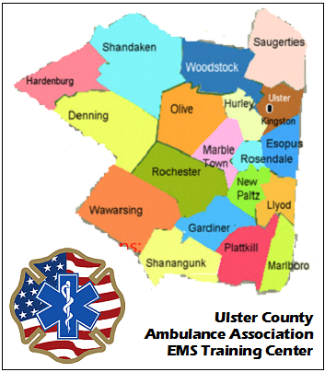
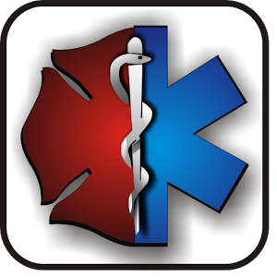

EMT Original &
EMT Refresher Challenge* Programs
Course Start: 09/05/17 State Exam: 01/18/18

Tuesday & Thursday Evenings: 7PM to 10PM &
Some Saturdays: 9AM to 4PM
St. Peter’s Elementary School
Keator Avenue, Rosendale, NY 12472

* The EMT Refresher / Challenge program has adopted the National Emergency Medical Services Educational Standards and uses both written and practical examinations to uncover areas of weakness in didactic knowledge and practical skill proficiency. The student will only be required to attend those sessions that are mandatory and the sessions related to the challenge exam topics the student failed.

Text Books: AAOS Emergency Care of the Sick and Injured
ASHI CPR/AED for the Professional Rescuer
Instructors: Dot Bailin / Ron Fields
For Registration &
Information contact: Dot Bailin: 845-667-4326

