ULSTER COUNTY PERSONNEL DEPARTMENT
244 Fair Street, PO Box 1800, Kingston, New York 12402-1800
Main: (845) 340-3550
Exam Hotline: (845) 334-5454
Fax: (845) 340-3592
 | PATRICK K. RYAN | 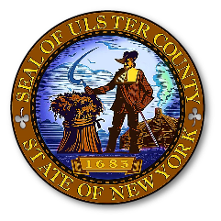 | SHEREE CROSS
 | County Executive |  | Personnel Officer
 |  |  | JAMES FARINA
 |  |  | Director of Employee Relations

Mandatory Training 2021
Attestation Form

The Ulster County Policy requires all County Employees to complete Mandatory Training every year. By signing and returning this Attestation Form to the Personnel Department you are confirming that you have completed your training for 2021 which consists of:
- The Mandatory Annual Training videos for 2021
Your signature confirms the completion of the program as well as your understanding of the components of the policies, your obligations to abide by the policies and that you know where to find the policies if you have any questions. At any time, questions can be directed to the Personnel Department.

NAME PRINTED: _______________________________________
SIGNATURE: ___________________________________________
Date of Completion: _________________________

**Once you have completed the training program, please return this Attestation Form to the Personnel Department: Attn: Cortney Moshier.
*** If you do not return this form, you will not get credit for completing the Mandatory Training for 2021.
****Training must be completed by Friday October 29, 2021.

