New York State Sexual Harassment Course through Alera

You will get an email with the subject heading that looks like this:
When you open the email, you will be asked to create a password for your account:
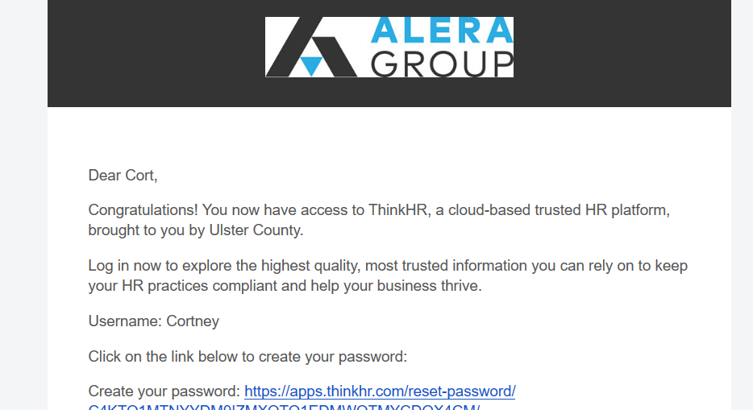
Once you create your password you will get an additional email giving you the link to the website where the training course is located:
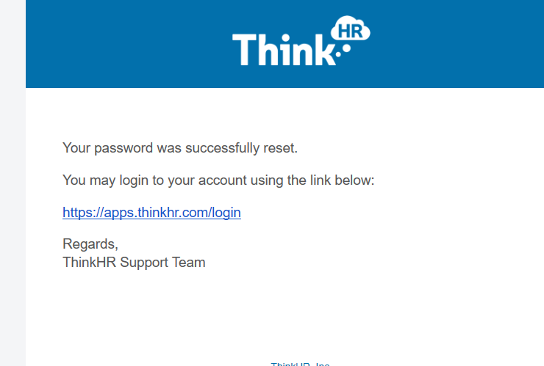

In a separate email, you will get the assigned course sent directly to you: An example of what your assigned course email will look like:
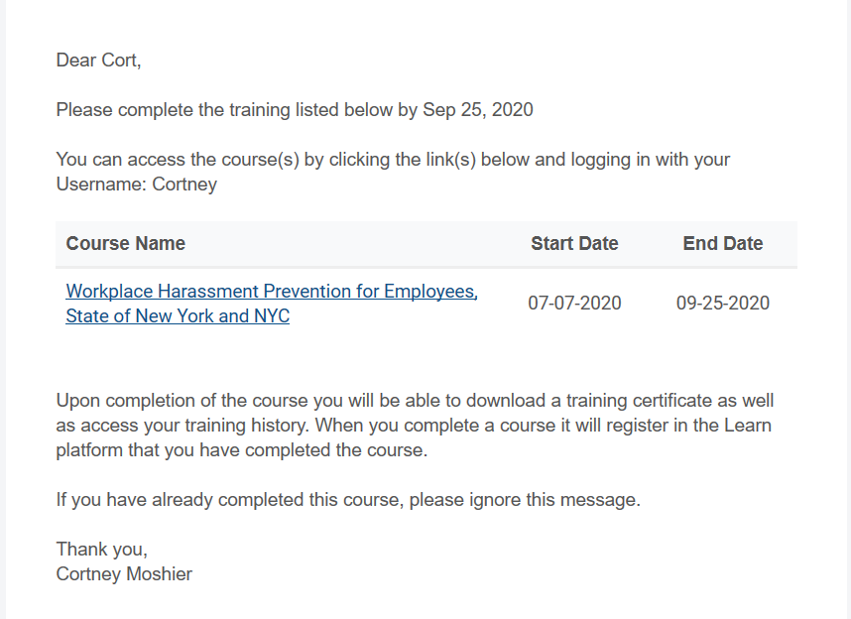
***please note this is just a sample, your email will look a bit different.

Once you sign in you will see the description of the class and to the right the START COURSE button.
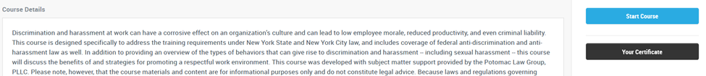

When you have completed your course, you will get a certificate of completion
**Once you have completed the course and watched the Mandatory Training Videos on the County Website, Personnel Page, make sure to sign, date and return the Attestation Form to the Personnel Department in order to get credit for the training.

