ULSTER COUNTY PERSONNEL DEPARTMENT
244 Fair St., P.O. Box 1800, Kingston, New York 12402-1800
Telephone: 845-340-3550
Fax: 845-340-3592
JEN METZGER
County Executive

KEVIN M. ROACH
Benefits Administrator/
FMLA Coordinator

DAWN SPADER
Personnel Director

JAMES FARINA
Director of Employee Relations

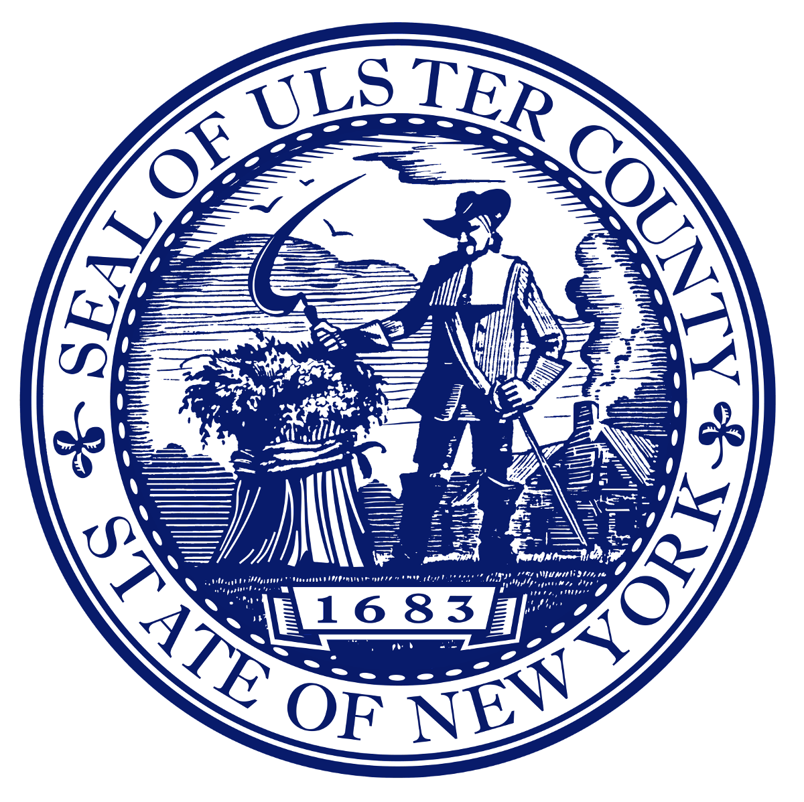

Parental Leave Program Request Form

Employee Name: ______________________________________Emp #: ____________

Mailing address: _________________________________________________________

Best contact phone #’s: _________________________________________________

Employee’s email address: _______________________________________________

Department: _________________ Supervisor: ________________________________

Date of Full Time Hire (M/Y): ________(Must be at least 6 mths prior to due date)

Anticipated date of birth: ______________________

Employee signature: ___________________________________

Date: ________________

Please file this request with your department FMLA representative.
For Personnel Use Only
Date Rec’d:_____________ Date Approved:___________ Date sent to Dept:__________

Proof of Birth Received: yes no Type:_________________
Version 03/26/2025

Version 03/26/2025

