Ulster County Area Transit
Title Vl Plan

December 2016
Revised December, 2018

TABLE OF CONTENTS PAGE

Introduction ………………………………………………………………………………………………………….. 03

Overview of Services………………………………………………………………………………………………. 03

Policy Statement and Authorities ……………………………………………………………………….…… 04

Complaint Policy and Procedure…………………………………………………………………………..….. 05

Plan Approval Document ………………………………………………………………………………………... 08

Organization and Title VI Program Responsibilities …………………………………………………. 09

Procedures for Notifying the Public of Title VI Rights ………………………………………………. 10

Public Outreach and Involvement……………………………………………………………………………. 12

Language Assistance Plan for Persons with Limited English Proficiency (LEP) ………….. 15

Requirements of Transit Providers ……………………………………………………………………….… 18

APPENDICES

A Title VI Complaint Form ……………………………………………………………………………………………….. 21
A-1 Complaint Policy and Procedure in English………………………………………………………………..… 22
A-2 Complaint Policy and Procedure in Spanish………………………………………………………………... 24
B Title VI Notice to the Public…………………………………………………………………………………………… 26
Title VI Notice to the Public Posting……………………………………………………………………………….. 27
C Investigations, Lawsuits, Complaint Log……………………………………………………………………….… 28
D Summary of Outreach Efforts………………………………………………………………………………………... 29

- INTRODUCTION

Title VI of the Civil Rights Act of 1964 prohibits discrimination on the basis of race, color, or national origin in programs and activities receiving Federal financial assistance. Specifically, Title VI provides that "no person in the United States shall, on the ground of race, color, or national origin, be excluded from participation in, be denied the benefits of, or be subjected to discrimination under any program or activity receiving Federal financial assistance". (42 U.S.C. Section 2000d)
Recipients of public transportation funding from FTA and Ulster County Area Transit (UCAT) are required to develop policies, programs, and practices that ensure that federal and state transit dollars are used in a manner that is nondiscriminatory as required under Title VI.
This document details how UCAT incorporates nondiscrimination policies and practices in providing services to the public. UCAT’s Title VI policies and procedures are documented in this plan and its appendices and attachments. This plan will be updated periodically as necessary, and at least every three years to incorporate changes and additional responsibilities that arise.

- Overview of Services

Ulster County Area Transit is a regional public transportation agency, and as such, provides a variety of transportation services, including fixed route, paratransit, and dial a ride service to the towns and villages of Kingston, New Paltz, Saugerties, Ellenville, Rosendale, Woodstock, Phoenicia, Wallkill, Marlboro, Poughkeepsie and Newburgh, area colleges, major medical centers, and senior housing complexes. From the Planning Departments Long Term Transportation Study, UCAT assessed that our fixed routes cover most of the densely populated LEP areas of the County. Therefore there is frequent use of our service throughout the County.

Paratransit service is operated by UCAT and it is for people who qualify under the eligibility requirements for the Americans with Disabilities Act (ADA). Para transit is provided within a defined service area, during the dame hours and days as fixed route service and in compliance with applicable state and federal laws for service to people whose disability prevents them from using fixed route bus service.

Dial a Ride services all of Ulster County for residents that call next day for shopping or medical services that do not live along the fixed route service.

- POLICY STATEMENT AND AUTHORITIES

Title VI Policy Statement

Ulster County Area Transit is committed to ensuring that no person shall, on the grounds of race, color, national origin, as provided by Title VI of the Civil Rights Act of 1964 as amended; the Federal Register; U.S. Department of Transportation 23; Code of Federal Regulation (CFR), Part 200.9 and 49 CFR, Parts 21, 26 and 27, Part V dated December 6, 2000; and,

Whereas, the UCAT administers programs of the U.S. DOT, and abides by U.S. DOT 23 and 49 CFR Parts 200.9 and 21, 26 and 27, respectively; and, in the event UCAT distributes federal aid funds to another government entity, UCAT will include Title VI language in all written agreements and will monitor for compliance; and

The Director of the UCAT or his/her designee shall implement the UCAT Title VI Policy Document for the UCAT Transportation Area as documented by the U.S. Bureau of the Census through the following methods:

The UCAT Title VI Manager, Carolyn J. Hargrove is responsible for initiating and monitoring Title VI activities, preparing required reports, and other responsibilities as required by Title 23 Code of Federal Regulations (CFR) Part 200, and Title 49 CFR Part 21.

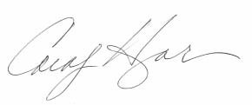
Carolyn J Hargrove Director of Public Transit January 7, 2017
Authorities

Title VI of the 1964 Civil Rights Act provides that no person in the United States shall, on the grounds of race, color, or national origin, be excluded from participation in, be denied the benefits of, or be otherwise subjected to discrimination under any program or activity receiving federal financial assistance (refer to 49 CFR Part 21). The Civil Rights Restoration Act of 1987 broadened the scope of Title VI coverage by expanding the definition of the terms “programs or activities” to include all programs or activities of Federal Aid recipients, sub recipients, and contractors, whether such programs and activities are federally assisted or not.

The UCAT Director and his/her designee shall be responsible for monitoring the implementation of UCAT Title VI Plan, but not necessarily limited to the following:

  - Receiving and, if necessary, assisting with the writing of discrimination complaints which are filed by users of UCAT plans, programs, or services.

  - Upon request, providing UCAT users with copies of the UCAT Title VI Plan.

IV COMPLAINT POLICY AND PROCEDURE

The Ulster County Area Transit (UCAT) shall have in effect the complaint process noted below which incorporates the elements of due process. These procedures cover all complaints regarding UCAT programs or activities filed under Title VI of the Civil Rights Act of 1964 or 49 CFR 21, “Nondiscrimination in the Federally-Assisted Programs of the United States Department of Transportation.” The process follows the steps identified below:

The following measures will be taken to resolve Title VI complaints:

- A formal complaint must be filed within 180 days of the alleged occurrence. Complaints shall be in writing and signed by the individual or his/her representative, and will include the complainant’s name, address and telephone number; name of alleged discriminating official, basis of complaint (race, color, national origin ), and the date of alleged act(s). A statement detailing the facts and circumstances of the alleged discrimination must accompany all complaints.

The County strongly encourages the use of the attached Ulster County Area Transit, Title VI Complaint Form when filing official complaints.

The preferred method is to file your complaint in writing using the Ulster County Area Transit, Title VI Complaint Form, and send it to:

Title VI Coordinator
Ulster County Area Transit
1 Danny Circle
Kingston, NY 12401

- In the case where a complainant is unable or incapable of providing a written statement, a verbal complaint of discrimination may be made to the City’s Title VI Coordinator. Under these circumstances, the complainant will be interviewed, and the County’s Title VI Coordinator will assist the Complainant in converting the verbal allegations to writing.

- When a complaint is received, the Title VI Coordinator will provide written acknowledgment to the Complainant, within ten (10) days by registered mail.

- If a complaint is deemed incomplete, additional information will be requested, and the Complainant will be provided 60 business days to submit the required information. Failure to do so may be considered good cause for a determination of no investigative merit.

A complaint may be dismissed for the following reasons:

  - The Complainant requests the withdrawal of the complaint.

  - The Complainant fails to respond to repeated requests for additional information needed to process the complaint.

  - The Complainant cannot be located after reasonable attempts.

- Within 15 business days from receipt of a complete complaint, Ulster County Area Transit will determine its jurisdiction in pursuing the matter and whether the complaint has sufficient merit to warrant investigation. Within five (5) days of this decision, the Title VI Coordinator or his/her authorized designee will notify the Complainant and Respondent, by registered mail, informing them of the disposition.

  - If the decision is not to investigate the complaint, the notification shall specifically state the reason for the decision.

  - If the complaint is to be investigated, the notification shall state the grounds of Ulster County Area Transit’s jurisdiction, while informing the parties that their full cooperation will be required in gathering additional information and assisting the investigator.

- When Ulster County Area Transit does not have sufficient jurisdiction, the Title VI Coordinator or his/her authorized designee will refer the complaint to the appropriate State or Federal agency holding such jurisdiction.

- If the complaint has investigative merit, the Title VI Coordinator or his/her authorized designee will fully investigate the complaint. A complete investigation will be conducted, and an investigative report will be submitted within 60 days from receipt of the complaint. The report will include a narrative description of the incident, summaries of all persons interviewed, and a finding with recommendations and conciliatory measures where appropriate. If the investigation is delayed for any reason, the Title VI Coordinator will notify the appropriate authorities, and an extension will be requested.

- The Title VI Coordinator or his/her authorized designee will issue letters of finding to the Complainant and Respondent within 90 days from receipt of the complaint.

- If the Complainant is dissatisfied with Ulster County Area Transit’s resolution of the complaint, he/she has the right to file a complaint with the:

Federal Transit Administration Office of Civil Rights
Attention: Title VI Program Coordinator
East Building, 5th Floor-TCR
1200 New Jersey Ave
SE Washington DC 20590

FTA Complaint procedures can also be found on the FTA web site at: www.fta.dot.gov. These procedures are also outlined in FTA Circular 4702.1A, Chapter IX.

See
Appendices A Title VI Complaint Form pg. 21
Appendices A -1 Complaint Form English pg. 22
Appendices A -2 Complaint Form Spanish pg. 24
Appendices B Title VI Notice to the Public pg. 26

The UCAT maintains a list or log of all Title VI investigations, complaints and lawsuits, pertaining to its transit-related activities.

There have been no complaints, investigations, or lawsuits in the past three years.

See Appendices C Investigation, Complaint Lawsuit Log pg. 28

- Plan Approval Document

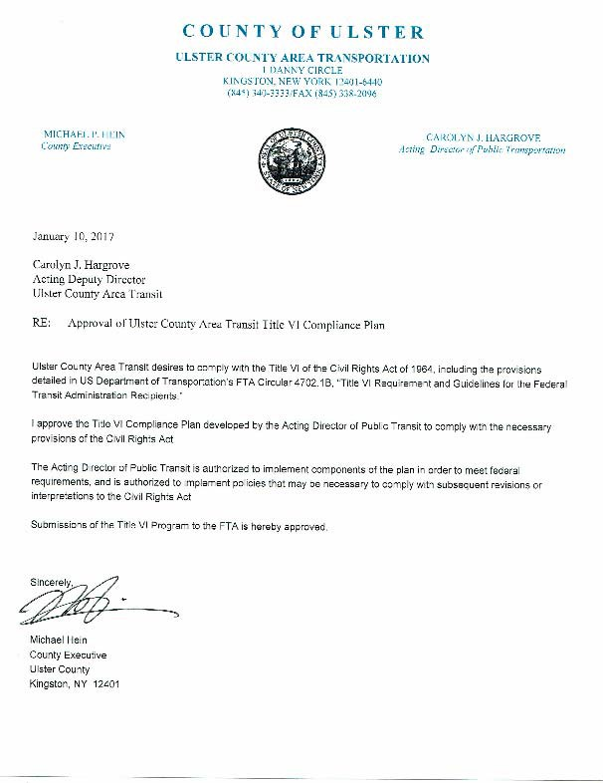

- Organization and Title VI Program Responsibilities

The UCAT Director of Public Transportation is responsible for ensuring implementation of the agency’s Title VI program. Title VI program elements are interrelated and responsibilities may overlap. The specific areas of responsibility have been delineated below for purposes of clarity.

Overall Organization for Title VI
The Title VI Manager and staff are responsible for coordinating the overall administration of the Title VI program, plan, and assurances, including complaint handling, data collection and reporting, annual review and updates, and internal education.

Detailed Responsibilities of the Title VI Manager
The Title VI Manager is charged with the responsibility for implementing, monitoring, and ensuring compliance with Title VI regulations. Title VI responsibilities are as follows:

- Process the disposition of Title VI complaints received.

- Collect statistical data (race, color or national origin) of participants in and beneficiaries of agency programs, (e.g., affected citizens, and impacted communities).

- Conduct Title VI reviews of construction contractors, consultant contractors, suppliers, and other recipients of federal-aid fund contracts administered through the agency.

- Conduct training programs on Title VI and other related statutes for agency employees.

- Develop Title VI information for dissemination to the general public and, where appropriate, in languages other than English.

- Identify and eliminate discrimination.

- Establish procedures for promptly resolving deficiency status and writing the remedial action necessary, all within a period not to exceed 90 days.

General Title VI responsibilities of the agency

The Title VI Manager is responsible for:

Data collection

To ensure that Title VI reporting requirements are met, UCAT will maintain:
  - A database or log of Title VI complaints received. The investigation of and response to each complaint is tracked within the database or log.

  - A log of the public outreach and involvement activities undertaken to ensure that minority and low-income people had a meaningful access to these activities.

Notifying the Public of Title VI Rights

Ulster County Area Transit operates its programs and services without regard to race, color, or national origin, in accordance with Title VI of the Civil Rights Act of 1964.
To obtain additional information about your rights under Title VI:
Contact Director of Ulster County Area Transit
If you believe you have been discriminated against on the basis of race, color, or national origin by Ulster County Area Transit you may file a Title VI complaint by completing, signing, and submitting the agency’s Title VI Complaint Form.
How to file a Title VI complaint with Ulster County Area Transit
- To obtain a Complaint Form from Ulster County Area Transit contact:
Title VI Coordinator
Ulster County Area Transit
1 Danny Circle
Kingston, NY 12401

In addition to the complaint process at Ulster County Area Transit, complaints may be filed directly with the:

Federal Transit Administration Office of Civil Rights

Attention: Title VI Program Coordinator

East Building, 5th Floor-TCR

1200 New Jersey Ave

SE Washington DC 20590

Complaints must be filed within 180 days following the date of the alleged discriminatory occurrence and should contain as much detailed information about the alleged discrimination as possible.

The form must be signed and dated, and include your contact information.

Website: www.co.ulster.ny.us/ucat

If information is needed in another language, contact: 845-384-6269

Title 49 CFR Section 21.9(d) requires recipients to provide information to the public regarding the recipient’s obligations under DOT’s Title VI regulations and apprise members of the public of the protections against discrimination afforded to them by Title VI. At a minimum, UCAT shall disseminate this information to the public by posting a Title VI notice on the agency’s website and in public areas of the agency’s office(s), including the reception area, meeting rooms, in federally funded vehicles, and bus schedules.

Website: www.co.ulster.ny.us/ucat

The Ulster County Area Transit (UCAT) shall have in effect the complaint process noted in section IV Complain Policy and Procedures. These procedures cover all complaints regarding UCAT programs or activities filed under Title VI of the Civil Rights Act of 1964 or 49 CFR 21, “Nondiscrimination in the Federally-Assisted Programs of the United States Department of Transportation.”

Instructions for filing Title VI complaints are posted on the agency’s website and in posters on the interior of each vehicle operated in passenger service and agency’s facilities, and
are also included on UCAT‘s schedules.

Posting:

Public Outreach and Involvement

It is the policy of Ulster County Area Transit to have a proactive public involvement process that provides complete information, timely public notice, and full public access to UCAT activities at all key stages in the decision making process. It is also UCAT’s policy to involve the public early in the planning process, and to actively seek out the involvement of communities most affected by particular plans or projects. Furthermore, it is a goal of the community involvement policy that the Region’s transportation plans and programs are developed in a manner that assures that the public, and affected communities in particular, are afforded ample opportunity to participate in the development of such plans.
UCAT’s Public Participation Plan also provides a framework for focused efforts to identify, seek out and engage populations that have traditionally been underserved by existing transportation systems, including: minority populations, low-income populations, non- English speakers and those with limited English proficiency, older persons and persons with disabilities.
The foundation for these efforts is stated in Title VI of the Civil Rights Act of 1964:
“…No person in the United States shall, on the basis of race, color, or national origin be excluded from participation in, be denied the benefits of, or be subjected to discrimination under any program receiving Federal financial assistance…”
--Title VI of the Civil Rights Act of 1964 (42 U.S.C. 2000)
Further reinforcement was established by the President’s 1994 Executive Order on Environmental Justice, which states:
“…Each Federal agency shall make achieving environmental justice part of its mission by identifying and addressing, as appropriate, disproportionately high and adverse human health or environmental effects of its programs, policies, and activities on minority populations and low-income populations…”
--Executive Order 12898, Federal Actions to Address Environmental Justice in Minority Populations and Low-Income Populations, 1994

  - PUBLIC MEETINGS
    - Meeting Accessibility
      - With the exception of those meetings that are appropriate executive sessions, all meetings Ulster County Area Transit shall be open to the public.
      - Assistance for the sight and/or hearing-impaired, those with limited English proficiency or non-English speakers shall be provided with advanced notice. When possible, written materials will be made available in languages other than English that are relevant to local populations. Interpretation is available at meetings if 7 days’ notice is given to UCAT in advance.

      - UCAT Staff will provide contact information for assistance to individuals in need of auxiliary aids and services in the below mentioned meeting notice. In addition, the UCAT Staff will provide information in regards to the status of the building’s accessibility.
      - With consideration to the geographical area and diverse topics of concern to the public, Ulster County Area Transit shall schedule meetings at convenient and accessible facilities, locations, and times which will encourage attendance by the general public, and that are accessible and accommodating to persons with disabilities, older persons and the sight and/or hearing-impaired. Where possible, meeting places will be accessible by public transportation. Meeting locations shall be compliant with the Americans with Disabilities Act (ADA).

    - Meeting Notice
- Advertising shall be display advertising or equivalent or superior editorial form. Display advertisements need not be duplicated by legal advertisements.
- In an effort to actively engage minority and low-income populations, non- English speakers and those with limited English proficiency, older persons and persons with disabilities, and other populations traditionally underserved by the existing transportation system, announcements of meetings will be distributed to newspapers or other media that specifically target these groups as appropriate including Social Media CPO ( Community Based Organization), emails of Organizations, Faith base organizations. Cultural Centers. Transportation is provided upon request.
- Meeting announcements shall be provided on UCAT’s web site (www.co.ulster.ny.us/ucat), where they are translated into Spanish.
- All additional or rescheduled meetings, or special meetings of the public, shall be announced on the agency's web site (www.co.ulster.ny.us/ucat) no less than 72 hours prior to the meeting time.
- Any special MPO meetings that may be necessary for emergency action shall be advertised in a newspaper of general circulation within the region no less than 72 hours prior to the meeting time, and shall be announced on the agency's web site (www.co.ulster.ny.us/planning) no less than 72 hours prior to the meeting time.
- In the event that a major decision, as defined in this document, is to be considered for action at a meeting of the MPO, the MPO shall provide notice in a newspaper of general circulation within the region at least 30 days prior to said meeting summarizing the major decision which is subject to action, indicating where copies of any document for review can be obtained and where to send comments.

ACTIVITIES SUBJECT TO PUBLIC INVOLVEMENT
Ulster County Area Transit shall provide early and continuing public involvement opportunities throughout the transportation planning and programming process.

  - Planning Activities
Special emphasis shall be given to engaging the public in planning studies that form the basis for later programming decisions. Planning activities include corridor studies and special regional studies, environmental assessment studies, and development of the Long Range Transportation Plan. These activities offer the public the earliest opportunity to participate in the development of project proposals that might eventually be programmed for funding. Thus, UCAT shall make an extra effort to involve the affected community through methods such as local advisory committees, public information meetings, and newsletters. Cross reference B #2 describing other methods we seek to involve the community.

DEFINITION OF PUBLIC & STAKEHOLDERS
Ulster County Area Transit shall make an effort to inform and engage both the general public and stakeholders as appropriate.
  - General Program
As part of its general planning and programming process, Ulster County Area Transit will try to involve the following: citizens, member municipalities, affected public agencies, representatives of transportation agency employees or unions, public and private providers of transportation, representatives from disability groups, and other parties who have expressed an interest in the process.
  - Outreach to Special Groups – Environmental Justice (EJ)
Ulster County Area Transit shall also make a special effort to seek out and consider the needs of groups or communities traditionally not well served by existing transportation systems. These include, but are not limited to low- income households and minority households.
It is sometimes necessary to conduct an outreach effort to EJ communities, beyond that which is normally expended. At a minimum, Ulster County Area Transit shall identify groups that it needs to involve, add them to the appropriate mailing lists, and define methods for engaging them in relevant programs or projects. This requirement for special outreach efforts shall apply to both sections A and B above.
Ulster County Area Transit efforts in this regard shall be consistent with the Environmental Justice Executive Order (EO 12898) dated February 11, 1994, and other related guidance from the Federal Highway Administration (FHWA) and Federal Transit Administration (FTA).

ADEQUATE TIME FOR PUBLIC COMMENT
Ulster County Area Transit shall allow reasonable time for public review and comment at key decision points. These include, but are not limited to, action on the Long Range Transportation Plan and the Transportation Improvement Program (TIP). Minimum notification periods shall be as follows:

Reduction in services or rate changes – 30 days Adoption of the TIP & major TIP amendments – 30 day Adoption of the Long Range Transportation Plan & major amendments – 30 days

METHODS OF NOTIFYING THE PUBLIC
Ulster County Area Transit shall use appropriate methods to notify the public of its activities and of opportunities for public involvement. Determination of which methods to use must be done for each individual planning project or study. However, the minimum requirements are listed below.
  - Meeting Notices
A notice of each meeting shall be filed with every municipality office. In an effort to actively engage minority and low-income populations, non-English speakers and those with limited English proficiency, older persons and persons with disabilities, and other populations traditionally underserved by the existing transportation system, announcements of regularly scheduled meetings will be distributed to newspapers or other media that specifically target these groups as appropriate.

APPENDICE C: Outreach and Involvement

Language Assistance Plan for Persons with Limited English Proficiency (LEP)

Ulster County has prepared a Limited English Proficiency Plan to help identify reasonable steps for providing language assistance to persons with limited English proficiency (LEP) who wish to access services provided. As defined by Executive Order 13166, LEP persons are those who do not speak English as their primary language and have limited ability to read, speak, write, or understand English. This plan outlines how to identify a person who many need language assistance, the ways in which assistance may be provided, staff training that may be required, and notification to LEP persons regarding the availability of assistance.

LEP - APPLYING THE FOUR-FACTOR FRAMEWORK

Factor 1. The number and proportion of LEP persons in the service area who may be served.

Ulster County Area Transit assessed the number and proportion of LEP persons served or encountered in the eligible service population from the 2016 American Community Survey 5- year Estimates for New York State, Ulster County and determined that:

  - 180505 individuals in Ulster County Area Transit service area comprising 11.3 % of the population speak a language other than English.

  - Of those, 2085 individuals have limited English proficiency that is; they speak English less than “very well” or “not at all.” This is only 0.1 % of the overall population in the service area.
- In UCAT service area, of those persons with limited English proficiency:

• 88.7 % speak English only • 3.7 % speak into European languages • 5.8 % speak Spanish

• 1.0 % speak Asian and Pacific Islander languages • 0.7% other languages

Factor 2: The frequency with which LEP individuals come in contact with an Ulster County Area Transit program, activity, or service.

UCAT reviewed the frequency with which their staff have, or potentially have, contact with LEP persons. This includes phone inquiries or office visits.
  - To date, UCAT has had 0 requests for interpreters and 0 request for translated program documents.
  - UCAT staff has had very little contact with LEP persons
Per the 2010 American Community Survey, Ulster County does not have a large LEP population.

Ulster County Area Transit is a regional public transportation agency, and as such, provides a variety of transportation services, including fixed route, paratransit, and dial a ride service to the towns and villages of Kingston, New Paltz, Saugerties, Ellenville, Rosendale, Woodstock, Phoenicia, Wallkill, Marlboro, Poughkeepsie and Newburgh, area colleges, major medical centers, and senior housing complexes. From the Planning Departments Long Term Transportation Study, UCAT assessed that our fixed routes cover most of the densely populated LEP areas of the County. Therefore there is frequent use of our service throughout the County.

Paratransit service is operated by UCAT and it is for people who qualify under the eligibility requirements for the Americans with Disabilities Act (ADA). Para transit is provided within a defined service area, during the dame hours and days as fixed route service and in compliance with applicable state and federal laws for service to people whose disability prevents them from using fixed route bus service.

Dial a Ride services all of Ulster County for residents that call next day for shopping or medical services that do not live along the fixed route service.

Factor 3: The nature and importance of the program, activity, or service provided by Ulster County to the LEP Community.

There is no large geographic concentration of any type of LEP individuals in the service area for UCAT. The overwhelming majority of the population, 88.7%, speaks only English. As a result, there are few social, service, or professional and leadership organizations within the UCAT service area that focuses on outreach to LEP individuals. The Ulster County Area Transit staff is most likely to encounter LEP individuals through office visits, phone conversations, notifications from department staff regarding the results of service delivery. Examples of transit service destinations provided include, shopping, work, medical, school, attendance and participation at public meetings.

Factor 4: The resources/ interpretation services available to Ulster County Area Transit

Ulster County Area Transit contacted other departments within Ulster County who are willing to provide voluntary language translation and interpretation services if needed within a reasonable time period. Other language translation options could be provided by bilingual staff or by telephone from a professional interpretation service (Lingualinx, Inc.) for which UCAT would pay a fee. The UCAT website is also available in 36 languages.

UCAT LANGUAGE ASSISTANCE PLAN

Language Assistance Measures
When an in-person interpreter is needed, it should be determined what language is required. Notice of translation services will also be displayed in English and Spanish, the two most commonly spoken languages among the LEP populations. Once the LEP person’s language is determined, UCAT staff will contact a translator on staff or contact the translating service under contract (Lingualinx, Inc.) for assistance to understand the customer’s needs.

UCAT Staff Training:

The LEP Plan will be available for all employees in a hard copy format. This information will also be part of the UCAT staff orientation process for new hires. Training topics include:

- Understanding the Title VI LEP program responsibilities
- What language assistance UCAT offers
- How to access an interpreter
- Documentation of language assistance requests
- The importance of educating UCAT staff on its LEP program responsibilities and their obligation to provide language assistance
- Providing Notice of Available Language Service to LEP Person

- Ulster County Area Transit offers Spanish-speaking dispatch services upon request for all information regarding transit service including Fixed Route, para transit and to off-route requests. UCAT has eight Spanish-speaking employees for translation.

- The electronic telephone message offers English or Spanish.

- Dispatchers will take the name and telephone number of the client and have a Spanish- speaking dispatcher call back, if one is not available at the time of the call. If a Spanish speaking dispatcher is not available, we patch the customer through the radio to a Spanish speaking driver for interpretation.

- UCAT also has employees who speak Chinese, Romanian, Spanish and Italian. These employees can also be called upon to interpret, as needed.

- Title VI information is posted in English and Spanish on all of our buses and is monitored by the maintenance department during the monthly PM inspections to assure they are posted in the bus and in good order.

- Ulster County has a contract with an interpreting contractor, Lingualinx Inc., who will provide dispatch services in other languages, as needed.

- Ulster County’s website is available in Spanish and 36 additional languages.

- UCAT has translated its System-wide schedule which encompasses all of our schedules into Spanish.

- UCAT has a website with information about programs, policies and contacts for public transit access in Spanish. The website is promoted on all rate schedules dispersed to the community and mentions both the English and Spanish site addresses.

- UCAT distributes and collects surveys to determine passenger needs in English and Spanish.

- UCAT works with the Department of Social Services, the Department of Labor, Gateway Community Industries, The Resource Center for Accessible Living, the Hispanic Outreach Advisory Board, the Office for Aging, and Ulster-Greene ARC to ensure that all people who public transit access need get it.

- The Hispanic Outreach Advisory Board includes UCAT in all mailings, seminars and activities related to the Hispanic Community. UCAT attends all of the above. Hispanic Outreach Advisory Board is a nonprofit organization that provides access to and information about critically needed services such as transportation to residents in Ulster County. HOAB’s mission is to improve the quality of life for residents in the community through programs that promote education, health, economic development, financial literacy and the cultural arts.

- LAP refresher training is given on an annual basis to all employees during our safety and sensitivity training day in September/October.

- Assistance for the sight and/or hearing-impaired, those with limited English proficiency or non-English speakers shall be provided with advanced notice. When possible, written materials will be made available in languages other than English that are relevant to local populations. Interpretation is available at meetings if 7 days’ notice is given to UCAT in advance.
The LAP plan is reviewed and trained annually with all UCAT staff.

Requirements of Fixed Route Transit Providers

Service Policy

UCAT operates 17 fixed routes, para transit and dial a ride services.

All buses are housed at the UCAT facility at 1 Danny Circle Kingston, NY.

All UCAT vehicles are low floor and are deployed on frequent service and ridership requires. Bus assignment takes into account the operating characteristics of buses of various lengths, which are matched to the operating characteristics of the route. Routes with lower ridership may be assigned cutaways or 30 ft. buses rather than the 35 or 40 foot buses

Ulster County Area Transit does not meet the threshold as defined in Chapter IV. UCAT
Operates less than 50 fixed route vehicles in peak service and is located in urbanized area of less than 200,000 people. UCAT operates 17 fixed routes.

- Service Amenities:

All UCAT buses are equipped with: Air conditioners, free Wi-Fi, ramps, and bike racks.

Service schedules are available on all buses, at the UCAT transit center and on the UCAT website.

Bus shelters with benches are supplied to villages, towns, senior residents, stores, park and rides, etc., upon request along the service area.

www.co.ulster.ny.us/ucat

Service Standards

Ulster County Area Transit the following service standards for our fleet of buses:

On Time performance:

On time performance is measured using specific time points along the route as noted on the schedule. Fixed route buses are prohibited from running early. On time performance is measured using a 5 minute late window.

Ninety percent of UCAT transit vehicle will complete their established runs no more than 5 minutes late. On time performance is monitored by using TripSpark software reporting.

All buses are air conditioned and low floor. Vehicle headway ranges from ½ hour to 2 hours on most fixed routes depending on the route and distance. Headway can be as much as 6 hours on limited service routes. Service hours are Mondays through Fridays from 5:20 AM to 10:30 PM. Saturdays and Sundays from 8:00 AM to 6:30PM.

The following charts shows the Vehicle load, Vehicle Headway, Service availability and on time performance for each mode.

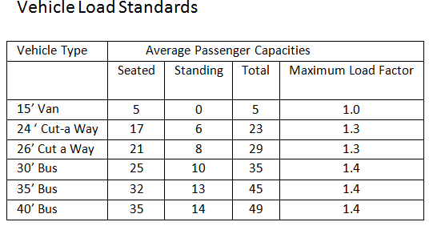

Headway and On Time Performance Chart

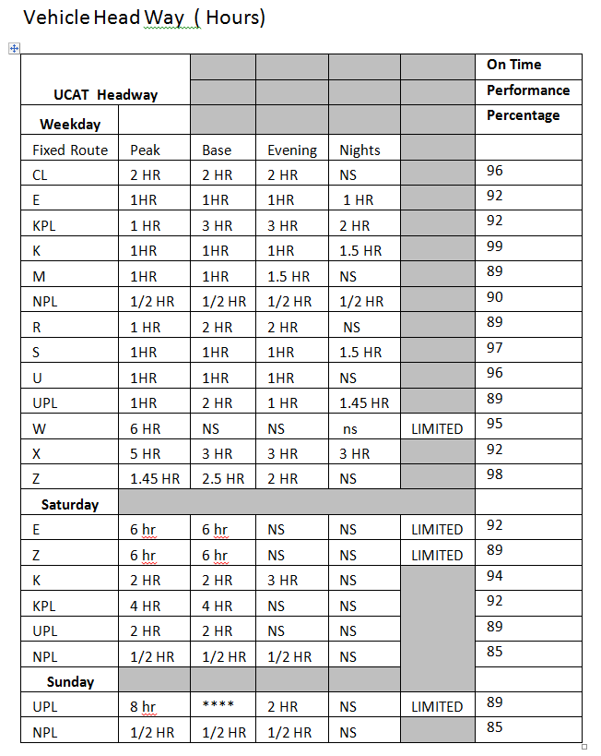

Minority and LEP Demographic Analysis

Ulster County Area Transit operates less than 50 fixed route vehicles in peak service but does evaluate the demographics

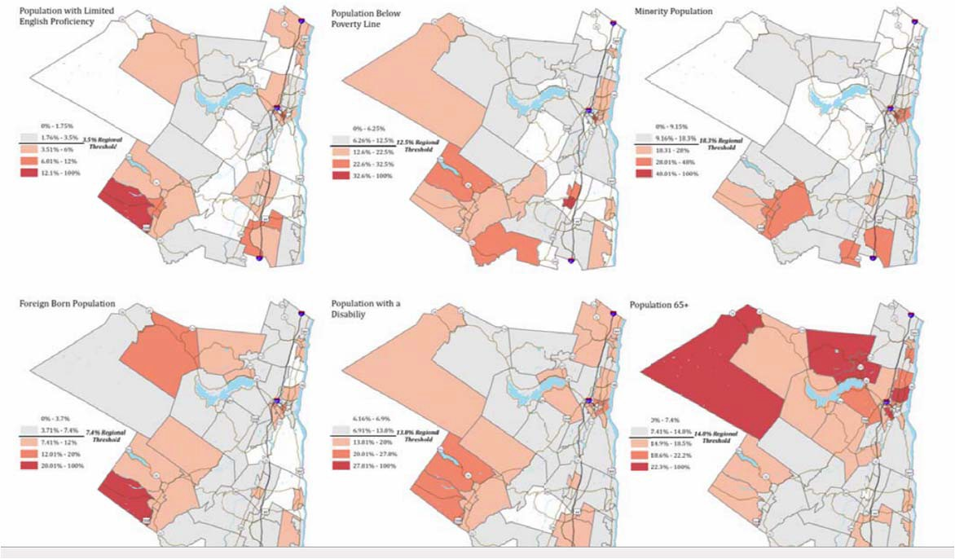

The Ulster County Planning Department finalized a long term transportation plan addressing Title VI and Environmental Justice. It can be accessed at http://www.co.ulster.ny.us/planning/tran.html

Monitoring Language Needs and Implementation
On an ongoing basis, Ulster County Area Transit will assess changes in demographics, types of services or other needs that may require reevaluation of this policy and its procedures. In addition, Ulster County Area Transit will regularly assess the efficacy of these procedures, including but not limited to mechanisms for securing interpreter services, equipment used for the delivery of language assistance, complaints filed by LEP persons, feedback from patrons and community organizations, etc. UCAT works with the Department of Social Services, the Department of Labor, Gateway Community Industries, the Resource Center for Accessible Living, the Hispanic Outreach Advisory Board, the Office for Aging, and Ulster-Greene ARC.

Facility Site Equity Analysis
Ulster County Area Transit has not identified a site or location for a new facility or constructed a facility during this period.

Sub recipients
Ulster County Area Transit does not oversee any sub-recipients.

Board Selection
Ulster County Area Transit does not have any non-elected planning boards, advisory councils or committees.

Recipient Construction Facilities/Site Analysis
UCAT has not constructed any storage facilities, maintenance facilities or operations centers in the last three years.

APPENDICIE A

TITLE VI COMPLAINT FORM

Ulster County Area Transit is committed to ensuring that no person is excluded from participation in or denied the benefits of its services on the basis of race, color, or national origin, as provided by the Title VI of the Civil Rights Act of 1964, as amended. The Title VI complaints must be filed within 180 days from the date of the alleged discrimination. Ulster County will review this claim and acknowledge receipt within 10 days and issue letters of finding to the Complainant and Respondent within 90 days from receipt of the complaint. UCAT will send progress reports every 30 days.

Date of Filing:

Name (Complainant): Phone:

Address: (City, State, Zip code)

Phone: Email:

Please indicate on what grounds you believe you have been discriminated against.
Check all that apply. [ ] Race [ ] Color [ ] National Origin
Date of Alleged Incident:

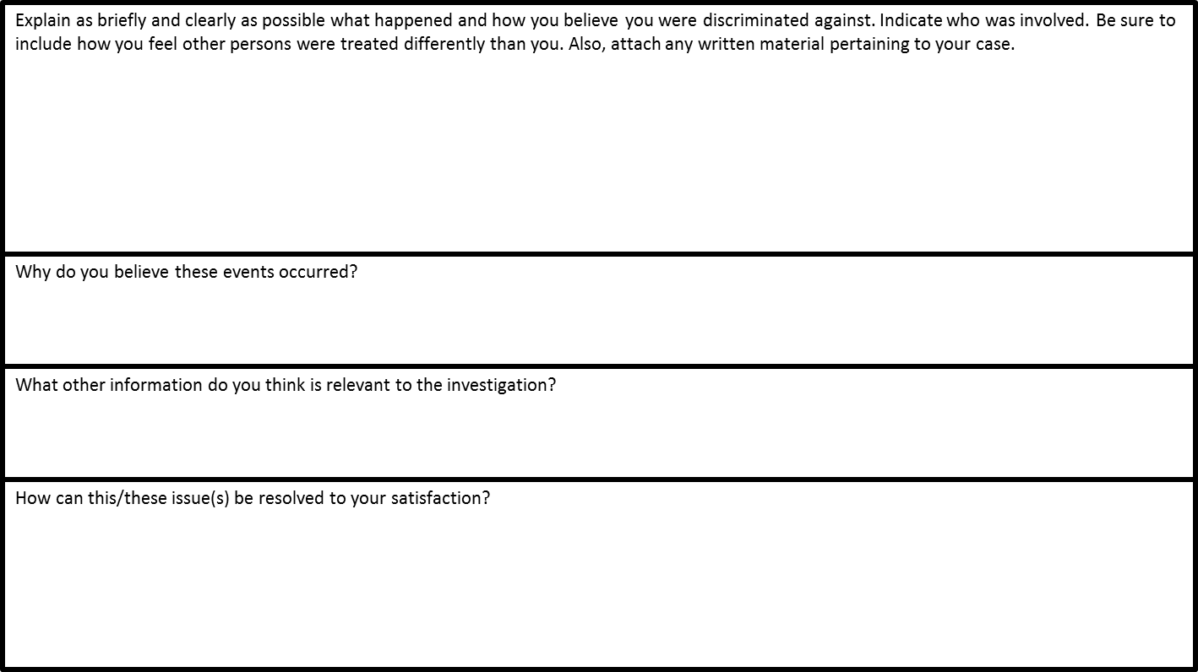

Please list below any person(s) we may contact for additional information to support or clarify your complaint. (Witnesses, fellow employees, supervisors, others): _________________________________________________________________________________________________________________________________________________

__________________________________________________________________________________________________________________________________

If you have an attorney representing you concerning the matter raised in this complaint, please provide the following:

Name: Phone:

Address:

Email: _

APPENDICIE A-1
C O U N T Y O F U L S T E R

ULSTER COUNTY AREA TRANSPORTATION
1 DANNY CIRCLE KINGSTON, NEW YORK 12401-6440
(845) 340-3333/FAX (845) 338-2096

MICHAEL P. HEIN CAROLYN J. HARGROVE
County Executive Director of Public Transportation

COMPLAINT POLICY AND PROCEDURE

The Ulster County Area Transit (UCAT) shall have in effect the complaint process noted below which incorporates the elements of due process. These procedures cover all complaints regarding UCAT programs or activities filed under Title VI of the Civil Rights Act of 1964 or 49 CFR 21, Circular 4702.1B “Nondiscrimination in the Federally- Assisted Programs of the United States Department of Transportation.” The process follows the steps identified below:

The following measures will be taken to resolve Title VI complaints:

- A formal complaint must be filed within 180 days of the alleged occurrence. Complaints shall be in writing and signed by the individual or his/her representative, and will include the complainant’s name, address and telephone number; name of alleged discriminating official, basis of complaint (race, color, national origin, sex, disability, age), and the date of alleged act(s). A statement detailing the facts and circumstances of the alleged discrimination must accompany all complaints.

The County strongly encourages the use of the attached Ulster County Area Transit, Title VI Complaint Form when filing official complaints.

The preferred method is to file your complaint in writing using the
Ulster County Area Transit Title VI Complaint Form, and send it to:
Title VI Coordinator
Ulster County Area Transit
1 Danny Circle
Kingston, NY 12401

- In the case where a complainant is unable or incapable of providing a written statement, a verbal complaint of discrimination may be made to the City’s Title VI coordinator. Under these circumstances, the complainant will be interviewed, and the County’s Title VI Coordinator will assist the Complainant in converting the verbal allegations to writing.

- When a complaint is received, the Title VI Coordinator will provide written acknowledgment to the Complainant, within ten (10) days by registered mail.

- If a complaint is deemed incomplete, additional information will be requested, and the Complainant will be provided 60 business days to submit the required information. Failure to do so may be considered good cause for a determination of no investigative merit. A complaint may be dismissed for the following reasons:
  - The Complainant requests the withdrawal of the complaint.
  - The Complainant fails to respond to repeated requests for additional
information needed to process the complaint.
  - The Complainant cannot be located after reasonable attempts.

- Within 15 business days from receipt of a complete complaint, Ulster County Area Transit will determine its jurisdiction in pursuing the matter and whether the complaint has sufficient merit to warrant investigation. Within five (5) days of this decision, the Title VI Coordinator or his/her authorized designee will notify the Complainant and Respondent, by registered mail, informing them of the disposition.
  - If the decision is not to investigate the complaint, the notification shall
specifically state the reason for the decision.

  - If the complaint is to be investigated, the notification shall state the
grounds of Ulster County Area Transit’s jurisdiction, while informing
the parties that their full cooperation will be required in gathering
additional information and assisting the investigator.

- When Ulster County Area Transit does not have sufficient jurisdiction, the Title VI Coordinator or his/her authorized designee will refer the complaint to the appropriate State or Federal agency holding such jurisdiction.

- If the complaint has investigative merit, the Title VI Coordinator or his/her authorized designee will fully investigate the complaint. A complete investigation will be conducted, and an investigative report will be submitted within 60 days from receipt of the complaint. The report will include a narrative description of the incident, summaries of all persons interviewed, and a finding with recommendations and conciliatory measures where appropriate. If the investigation is delayed for any reason, the Title VI Coordinator will notify the appropriate authorities, and an extension will be requested.

- The Title VI Coordinator or his/her authorized designee will issue letters of finding to the Complainant and Respondent within 90 days from receipt of the complaint.

- If the Complainant is dissatisfied with Ulster County Area Transit’s resolution of the complaint, he/she has the right to file a complaint with the:

Federal Transit Administration
Office of Civil Rights
Title VI Program Coordinator East Building, 5th Floor-TRC
New Jersey Ave, SE
Washington D.C. 20950

FTA Complaint procedures can also be found on the FTA web site at: www.fta.dot.gov. These procedures are also outlined in FTA Circular 4702.1A, Chapter IX.

No active investigations have been instituted by any entities during the reporting period.

"Ulster County Makes It Happen "...www.co.ulster.ny.us/ucat

APPENDICIE A-2

Title VI Complaint and Investigation Procedure in Spanish

Title VI – Procedimientos de Demanda e Investigación
Estos procedimientos cubren todas las demandas presentadas bajo el Title VI of Civil Rights Act of 1964, Section
504 of Rehabilitation Act of 1973, y de Americans with Disabilities Act de 1990, para presuntos actos de discriminación en cualquiera de los programas o actividades administradas por el Lowell Regional Transit Authority (LRTA).

Estos procedimientos no impiden el derecho de presentar una demanda formal con otro Estado u otra Agencia Estatal o Federal o buscar consejo por vías privadas para la demanda de presuntos actos discriminatorios. El proceso será conducido para obtener una pronta resolución de la demanda al nivel administrativo mas bajo. La opción de una resolución por vía de mediación informal entre las partes afectadas y el LRTA será considerada como posible recurso a la resolución de la demanda. Cualquier individuo, grupo de individuos
o entidad que tenga la sospecha de haber sido objeto de discriminación, prohibida bajo el Title VI y relacionada con sus estatutos podrá presentar una demanda por escrito a la siguiente dirección postal:

Title VI Coordinator Ulster County Area Transit, 1 Danny Circle, Kingston NY 12401

Las siguientes medidas serán tomadas para la resolución de demandas bajo el Title VI:

1.) Una demanda oficial deberá ser presentada en un plazo de 180 días después del supuesto acto discriminatorio. Quejas deberán ser presentadas por escrito y firmadas por el individuo o su representante, y deberán incluir el nombre del denunciante, la dirección y numero de teléfono, nombre del presunto discriminante, bases de la demanda (raza, color, nacionalidad, sexo, minusvalía, edad) y la fecha del acto discriminatorio. Un documento detallando los hechos y las circunstancias del presunto acto discriminatorio deberá acompañar todas las demandas.

2.) Si el demandante no puede proveer la demanda por escrito, una demanda verbal de discriminación deberá ser presentada al UCAT Title VI Coordinator. Bajo estas circunstancias, el demandante será entrevistado y el FTA Title VI Coordinator asistirá al demandante a convertir la demanda verbal en demanda por escrito.

3.) Una vez recibida la demanda completa, el Title VI Coordinator tendrá 5 días para notificar por escrito y por correo certificado al demandante que la demanda ha sido recibida.

4.) Si la demanda es considerada incomplete, información adicional será requerida al demandante siendo notificado en los siguientes quince (15) días laborales desde que la demanda fue recibida. Al demandante se le concederán sesenta (60) días laborales para enviar la información solicitada. Si la información adicional requerida no es recibida, será considerada causa suficiente para no comenzar el proceso de investigación.

5.) Quince (15) días después de recibir la demanda completa, el UCAT determinara la jurisdicción para proceder con la demanda y si la misma tiene suficientes bases para comenzar la investigación. Cinco (5) días
después de tomar la decisión de si proceder o no con la investigación, el Administrador o su autorizado designado notificara al demanda demandante, por correo certificado, si la investigación seguirá adelante o no.
- Si la decisión es de no proceder con la investigación, la notificación especificara la razón/es por dicha decisión.
- Si la demanda es investigada, la notificación detallara el área de la jurisdicción del UCAT, mientras se informa a las partes que su total cooperación será requerida para reunir información adicional en caso de ser necesaria y colaborar con el investigador.

6.) Si el UCAT no tiene suficiente jurisdicción, el Administrador o su autorizado designado referirá la demanda a la apropiada agencia Estatal Federal que representa esa jurisdicción.

7.) Si se va a proceder con la demanda, el Administrador o su autorizado designado asignara un investigador. Una completa investigación será conducida, y detallada documentación de la investigación será enviada al Administrador en los siguientes cuarenta y cinco (45) días de haber recibido la demanda. El informe incluirá una descripción detallada del incidente, resumes de todas las entrevistas de las personas entrevistadas, los hallazgos encontrados y las recomendaciones.

8.) El Administrador o su autorizado designado mandara una carta con los hallazgos al demandante y al respondiente. Cuando sea apropiado, estas cartas incluirán medidas conciliadoras. Si la investigación fuese retrasada por alguna razón, el investigador notificara a las apropiadas autoridades, y una extensión de tiempo será solicitada.

9.) Si el demandante no esta satisfecho con la resolución del UCAT, el demandante tiene el derecho de presentar la demanda con el:

Federal Transit Administration
Office of Civil Rights
Title VI Program Coordinator East Building, 5th Floor-TRC
New Jersey Ave, SE
Washington D.C. 20950

Appendices B

Ulster County Area Transit
1 Danny Circle
Kingston, NY 12401
Notifying the Public of Rights under Title VI

Ulster County Area Transit operates its programs and services without regard to race, color, or national origin, in accordance with Title VI of the Civil Rights Act of 1964.
To obtain additional information about your rights under Title VI, contact Director of Ulster County Area Transit
If you believe you have been discriminated against on the basis of race, color, or national origin by Ulster County Area Transit you may file a Title VI complaint by completing, signing, and submitting the agency’s Title VI Complaint Form.
How to file a Title VI complaint with Ulster County Area Transit
1. To obtain a Complaint Form from Ulster County Area Transit contact:

Title VI Coordinator
Ulster County Area Transit
1 Danny Circle
Kingston, NY 12401

2. In addition to the complaint process at Ulster County Area Transit, complaints may be filed directly with the: Federal Transit Administration
Office of Civil Rights
Title VI Program Coordinator East Building, 5th Floor-TRC
New Jersey Ave, SE
Washington D.C. 20950

3. Complaints must be filed within 180 days following the date of the alleged discriminatory occurrence and should contain as much detailed information about the alleged discrimination as possible.

4. The form must be signed and dated, and include your contact information.

If information is needed in another language, contact: 845-384-6269

Title 49 CFR Section 21.9(d) requires recipients to provide information to the public regarding the recipient’s obligations under DOT’s Title VI regulations and apprise members of the public of the protections against discrimination afforded to them by Title VI. At a minimum, UCAT shall disseminate this information to the public by posting a Title VI notice on the agency’s website and in public areas of the agency’s office(s), including the reception area, meeting rooms, in federally funded vehicles, and bus schedules.
Website:www.co.ulster.ny.us/ucat

TITLE VI Posting on Buses, Schedules, Website, Lobby

APPENDICE C

Title VI Investigation, Complaint, Lawsuit Log

Check One:

X There have been no investigations, complaint and/or lawsuits filed against us since the last plan submission.

There have been investigations, complaints and/or lawsuits filed against us. See list below

 | Date  00/00/0000 | Summary  Basis of Complaint Race, color, or national origin | Status | Action Taken
Investigations
1.
Lawsuits
1.
Complaints
1.

No active investigations, complaints, and /or lawsuits have been instituted by any entities during the reporting period.

APPENDICE D

Ulster County Area Transit Community Outreach

February-16 | UARC
April-16 | Ulster Garden/Subsidized Housing
May-16 | Rosendale Seniors
July-16 | Ulster County Fair
August-16 | Live-Laugh Learn Senior Presentation
Feb-17 | Mental Health Association
Mar-17 | Ulster Gardens - Subsidized Housing
Mar-17 | St. Patrick’s Parade various groups
July-17 | Ride Share
August-17 | Live, Laugh, Learn Senior Presentation
September-17 | Marlboro Seniors/ Subsidized Housing
August-17 | SUNY New Paltz
October 1, 2017 | Trudy Farber- Ellenville
November 1, 2017 | Public Meeting- Integration Study
March-18 | Ulster Gardens - Subsidized Housing
March-18 | St Patrick’s Parade- various groups
March-18 | Ellenville Trudy Farber
April-18 | Service Surveys - English-Spanish
May-18 | Senior Advisory Committee
August-18 | Live, Laugh, Learn Senior Presentation
August-18 | SUNY New Paltz
August-18 | Senior Collision
August-18 | Service Surveys-English & Spanish
August-18 | Mini Job Fair- Employment Training
Kingston Community Radio:
4th Thursday of Every Month 920 AM

