ULSTER COUNTY EXECUTIVE
244 Fair St., P.O. Box 1800, Kingston, New York 12402
Telephone: 845-340-3800
Fax: 845-334-5724
MICHAEL P. HEIN
County Executive

ADELE B. REITER
Chief of Staff

KEN CRANNELL
Deputy County Executive

ROBERT SUDLOW
Deputy County Executive

JAMES J. HANSON
Budget Director

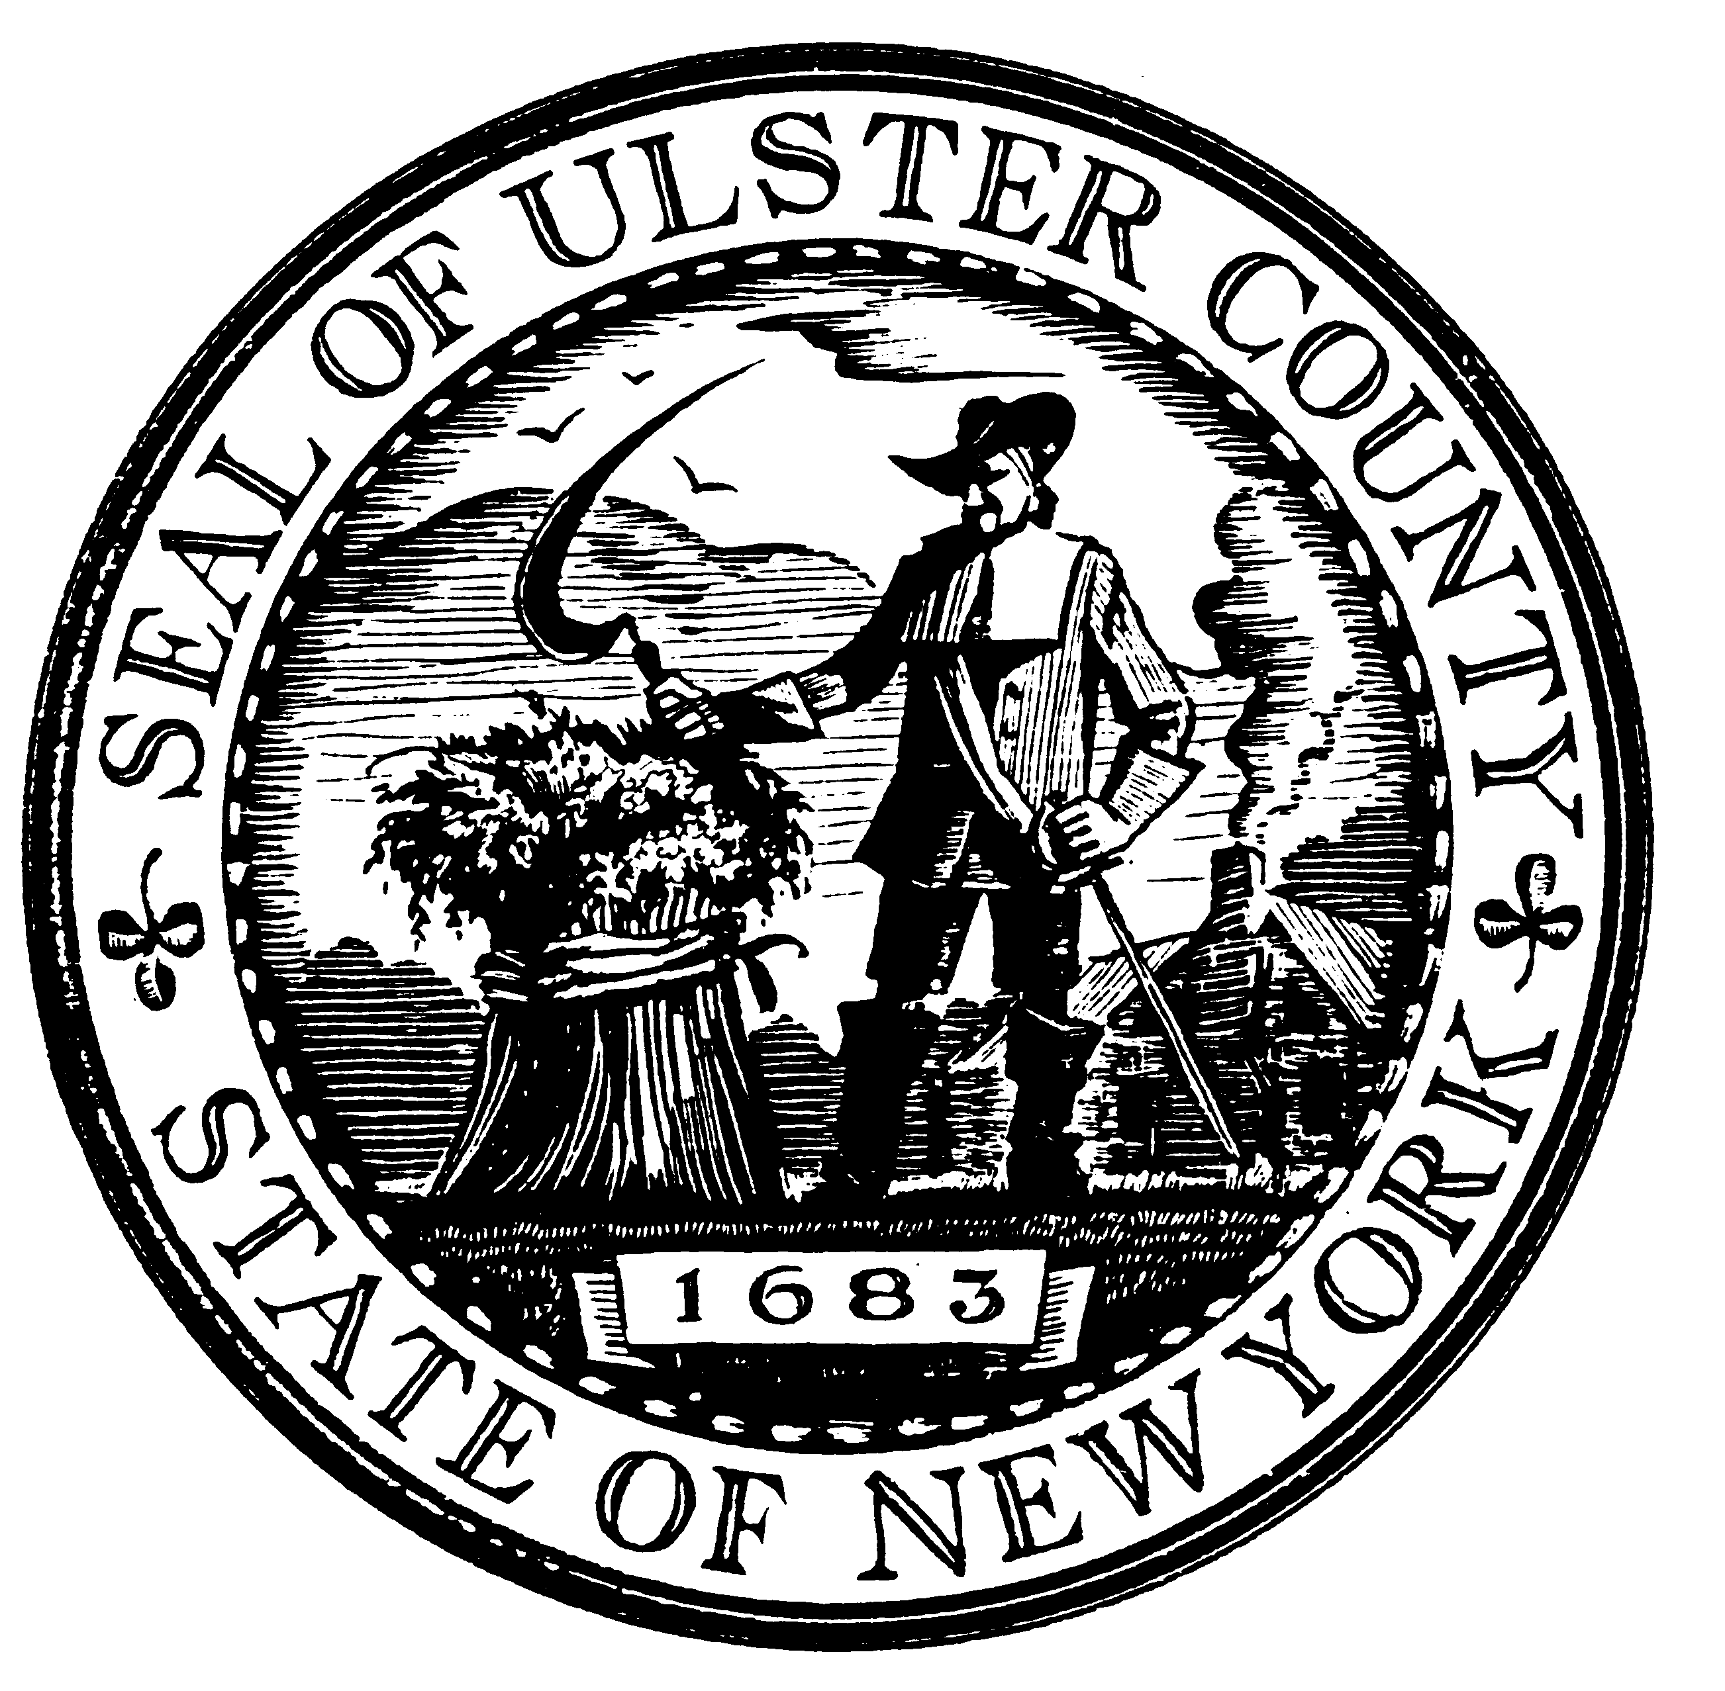

Collaborating to Bring History Alive:
Ulster County Cultural Heritage Conference

Staff, board members and volunteers from Ulster County’s cultural heritage organizations are invited to attend this free conference. Panelists will discuss attracting visitors and available resources to our County’s cultural heritage sites.

Where: Historic Huguenot Street
Deyo Hall at 18 Broadhead Avenue in New Paltz
When: Tuesday, February 28, 2012 from 9AM to noon
(snow date: March 6, 2012)
RSVP: By February 14, 2012 to: 334-5596 or
exec@co.ulster.ny.us

Brochure Exchange
Please bring materials to share.

Directions from the NYS Thruway

- Take exit 18 for NY-299 toward New Paltz/Poughkeepsie
- Turn left onto NY-299 W/Main St and go 1.4 miles
- Turn right onto N Chestnut St and go 0.3 miles
- Turn left onto Broadhead Avenue and go 0.1 miles
- Make a right into the parking lot

Weather Alert

Please check www.UlsterCountyNY.gov or email exec@co.ulster.ny.us if the weather forecast calls for dangerous driving conditions to see if the conference is being postponed until March 6th.

Tentative Conference Schedule

Register
County Executive Mike Hein – Welcome and Remarks
County Clerk Nina Postupack – Remarks

Panel 1: Attracting Visitors with Panelists:

Moderator - Tim Allred, Tour Guide, Hudson River Valley Tours
Rick Remsnyder, Director, Ulster County Department of Tourism: Getting Your Message Out - Resources and Services Available To Help You
Jim Edelstein, 33 Delivered: Using Social Media to Generate Excitement & Interest In You Historic Site
Cathy Ellis, Hudson River Valley Tours, LLC: Attracting and Understanding How To Work With Group Tours Operators
Kenneth F. Snodgrass, Executive Director of Locust Grove and Locust Lawn: Growing Your Audience Through Innovative Programs and Partnerships

Panel 2: Resources with Panelists:

Moderator – March Gallagher, Ulster County Deputy Director for Economic Development
Mark Castiglione, Acting Executive Director of the Hudson River Valley Greenway: Applying for Grant Funding
Erin M Tobin, Regional Director of Technical and Grant Programs for Eastern New York at the Preservation League of New York State: Preservation League Programs
Melinda Beuf, Director of Retention and Project Management at the Ulster County Development Corporation: Non-profit Funding from UCDC/IDA
Laurie Hancock, Office of the County Clerk Records Management: Importance of Archiving and Archiving Options

Networking and Next Steps

