Albany County:

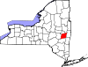

http://www.albanycounty.com/

Albany County Department of Public Works is responsible for the construction and maintenance of the stormwater conveyance system along County roads. The Commissioner of Public Works is designated as the County's Stormwater Management Officer, manages the County Stormwater system, and enforces the Illicit Discharge and Elimination Law.

Albany County Soil and Water Conservation District is a partner in promoting stormwater awareness by producing educational literature and supporting stormwater workshops for construction contractors and municipal officials.

III. Rural Fire Protection Program

Natural Resource Technical Assistance - The ACSWCD provides assistance to landowners, land managers, local government agencies, and other local interests in addressing a broad range of resource concerns. Natural resource management activities performed by the District include, but are not limited to:

Streambank protection/maintenance

Water supply protection/watershed management

Erosion & sediment control

Stormwater management

Drainage assistance

Aquatic weed management and control

Sewer District Annual Report is available online to the public.

Allegany County:
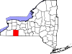
http://www.alleganyco.com/

Bronx County:
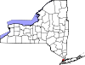

Broome County:
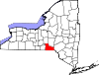

http://www.gobroomecounty.com/index2.php

EMC -

Natural Resources Committee - Promotes an understanding and sense of stewardship on the part of County residents with regard to the natural resources that surround us. Reviews proposals for development, promotes appropriate and consistent land use practices, supports and helps establish municipal Conservation Advisory Commissions (CAC's).

Recycling & Waste Management Committee - Advises County government on policy and programs related to solid waste management, including recycling, waste prevention, household hazardous waste disposal, composting and landfilling. The Nanticoke Landfill CAC, a sub-group, reviews and monitors activities at the County Landfill at Nanticoke and makes recommendations on mitigating impacts on the surrounding area.

Broome County Plan for Sustainable Econonic Development: www.thebcplan.com

Cattaraugus County:
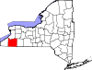

http://www.co.cattaraugus.ny.us/

Cayuga County:
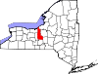

http://www.co.cayuga.ny.us/

Environmental Engineer
Bruce R. Natale
County Office Building, 5th Floor
160 Genesee Street
Auburn NY, 13021 map #1
Phone: (315) 253-1203
Email: envengr@cayugacounty.us

Chautauqua County:
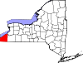

http://www.chemungcounty.com/

Chenango County:
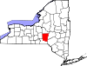

http://www.co.chenango.ny.us/

Clinton County:
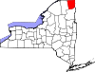

http://www.co.clinton.ny.us/

Columbia County:
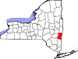

http://www.columbiacountyny.com/

Cortland County:
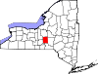

http://www.cortland-co.org/

Department of Solid Waste

Delaware County:
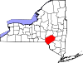

http://www.co.delaware.ny.us/

Department of Watershed Affairs

Dutchess County:
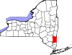

http://www.dutchessny.gov/

EMC

Dutchess Goes Green – Plan proposed by the County Executive

Department of Water and Wastewater Authority

Soil and Water Conservation District

Resource Recovery Agency

Erie County:
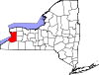

http://www.erie.gov/

Department of Environment and Planning –

Environmental Compliance:
The Division of Environmental Compliance Services (ECS) is a non-regulatory public assistance agency that provides technical and non-technical support to the Western New York community. ECS develops and implements programs in partnership with a variety of stakeholders to address the pressing environmental needs and concerns of the region.
ECS programs help Erie County businesses, municipalities, citizens and institutions understand and comply with environmental standards and regulations as well as initiate strategies to reduce and eliminate pollution and improve the quality of life in Western New York. These programs address: small business and local government pollution prevention; solid waste management; hazardous waste management; indoor air quality and, energy efficiency. The current environmental programs and services available in the ECS Division include:
- Municipal Stormwater
- Environmental Management Council
- Habitat Restoration Projects
- Diesel School Bus Initiative
- Pollution Prevention Technical Assistance
- Hospitality Sector Pollution Prevention
- Business Compliance Assistance
- County Facility Compliance Program
- Pesticides Neighbor Notification Law
- Septic System Pollution Prevention
- Mercury Pollution Prevention
- Household Hazardous Waste Collection
- Indoor Air Quality
- Solid Waste Management
- Solid Waste Reuse and Reduction
- Solid Waste Recycling
- Electronic & Computer Recycling
- Backyard Composting
- Purchasing Recycled Products
- C&D Debris Recycling Project
- Small Business Waste Reduction
- Rechargeable Battery Recycling
Community outreach and education is a vital component of many of the programs administered through the Division. ECS staff often participates in community events and assist local educators with presentations on a number of environmental topics. For more information, contact ECS at the number listed above.

Sewerage Management:

The DSM's role in this community is to safeguard the environment and our rate payers through the effective and efficient collection and treatment of sanitary wastewater. We continuously research initiatives that have been put into practice and found successful by innovative wastewater service providers throughout the world for the efficient and effective operation of their assets.

Essex County:
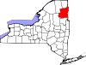

http://www.co.essex.ny.us/

Department of Community Development and Planning

Department of Public Works

Franklin County:
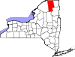

http://www.fcswcd.org/

Fulton County:
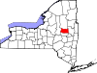

http://www.fulcony.com/

- Planning Department

- Solid Waste Department

Genesee County:
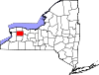

http://www.co.genesee.ny.us/

- Soil and Water Conservation District
- Planning Department
- Agricultural and Farmland Protection Plan
- GLOW Region Solid Waste Management Committee

* None of the above have websites/web pages.

Greene County:
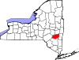

http://www.greenegovernment.com/

Planning Dept., Solid Waste Dept.

Hamilton County:
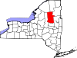

http://hamiltoncounty.com/

Herkimer County:
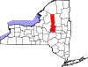

http://www.herkimercounty.org/content/

Highway Department

Jefferson County:
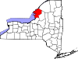

http://www.co.jefferson.ny.us/Jefflive.nsf/index12

Department of Recycling and Waste Management

Kings County:
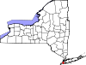

Lewis County:
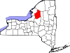

http://lewiscountyny.org/content

Solid Waste Department

Junkyard Inspector

Livingston County:
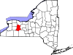

http://www.co.livingston.state.ny.us/

- Planning Department – Weatherization Program:

  - Funded by the State of New York, Division of Housing and Community Renewal, Energy Services Bureau, through a grant received from the U. S. Department of Energy, pursuant to the National Energy Conservation Policy Act.

  - What is Weatherization?
Weatherization is a means by which air can be prevented from entering and heat can be prevented from leaving a dwelling unit, thus increasing heating efficiency and savings.
  - Four basic steps of weatherization:
    - An application to the local agency in Geneseo to determine the income eligibility of the dwelling occupants.
    - A pre-weatherization inspection of the dwelling unit to determine its specific needs. (Energy audit.)
    - The weatherization of the unit.
    - A post-program inspection of the unit to review the work quality and effectiveness.
    - In addition, many units will be spotted for pre and post weatherization energy audits. These audits will determine the consumption rates of energy before and after the weatherization work on the unit thus determining the effectiveness.

- Water and Sewer Authority

- Highway Department

Madison County:
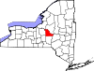

http://www.madisoncounty.org/

- Planning Department

- Solid Waste and Sanitation Department

- Highway Department

Monroe County:
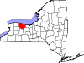

http://www.monroecounty.gov/

Montgomery County:
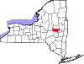

http://www.co.montgomery.ny.us/

- Montgomery County Soil and Water Conservation District

- Sanitary Sewer District No. 1

- USDA National Resource Conservation Service

- MOSA Solid Waste

Nassau County:
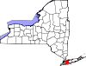

http://www.nassaucountyny.gov/

- Planning Commission

- Planning Federation

New York County:
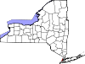

Niagara County:
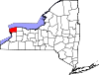

http://www.niagaracounty.com/

- Landfill/Recycling Center

Oneida County:
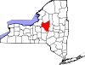

http://www.oneidacounty.org/

Department of Water Quality and Water Pollution Control

Onondaga County:
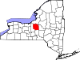

http://www.ongov.net/

- Department of Environmental Health

- Office of the Environment

- Department of Water Environment Protection

- Water Authority

- Resource Recovery Agency

- Energy Conservation Program

Ontario County:
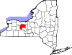

http://www.co.ontario.ny.us/

Orange County:
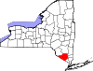

http://www.orangecountygov.com/

Division of Environmental Health

Environmental Facilities and Services

Orange County Water Authority

Orleans County:
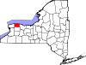

http://www.orleansny.com/

Planning, Highway

Oswego County:
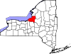

http://www.co.oswego.ny.us/govt-home.shtml

Solid Waste, Planning

Ostego County:
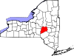

http://www.otsegocounty.com/

Department of Highways Forestry and Parks

Soil and Water Conservation District

Putnam County:
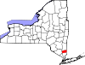

http://www.putnamcountyny.com/

Soil and Water Conservation District

Keep Putnam Healthy

Rennselaer County:
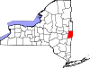

http://www.rensco.com/

Sewer District

Richmond County:
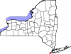

Rockland County:
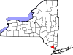

http://www.co.rockland.ny.us/

Division of Environmental Resources

St. Lawrence County:
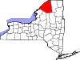

http://www.co.st-lawrence.ny.us/

Forestry Department

Soil and Water Conservation District

Saratoga County:
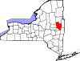

http://www.co.saratoga.ny.us/

Environmental Services

Soil and Water Conservation District

Schenectady County:
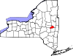

http://www.schenectadycounty.com/default.aspx?m=2

Conservation District

Schoharie County:
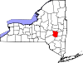

Schuyler County:
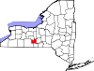

http://www.schuylercounty.us/

Watershed Protection Agency
Services and Regulatory Activity (What we do.)
- Onsite Wastewater Treatment System Program - Permitting, Design and Inspections for new and replacement systems
- Real Property Transfer Wastewater Treatment System Inspections and Water Quality Testing
- Lamoka Waneta Lakes Wastewater Treatment System Inspection Program
- Environmental Health Complaint Response and Referral
- Water Well Site Approval
- Water Quality Sampling
Schuyler County WPA has regulatory authority over wastewater treatment systems in the County. The WPA (through its contractual Professional Engineer) provides design and inspection services for most new and replacement wastewater treatment systems.
All real property transfers with a requested inspection (either the buyer, seller, lending institution or attorney) of the wastewater treatment system must be conducted by a representative of the WPA.
The WPA also has complete water quality sampling and monitoring services through our partnership with Eastern Laboratory Services, Ltd., a NY Certified Laboratory for drinking water, wastewater and solid waste. The WPA provides water quality sampling needs for a vast majority of regulated facilities within the County, as well as sampling services for most real estate property transfers, new well construction and some surface water sampling. A courier service provides delivery and pick up to our office Tuesday through Friday, excluding holidays and the day after holidays.
Fee Schedule (see composite fee schedule below in downloadable forms)
About the Watershed Protection Agency
An offshoot of the Schuyler County Watershed Department, created in 1973 by the Schuyler County Legislature, the Watershed Protection Agency (WPA) is an agency within the Public Health and Community Services Agency of Schuyler County. The original Watershed Department was created by the legislature to provide consistent and adequate disposal and treatment of wastewater generated from homes and other facilities not on a public sewer system, providing county-wide consistency, in an effort to protect public health and protect the water quality of our many lakes and streams.
The WPA is charged with the implementation of the Schuyler County Watershed Protection Law, last updated in 1994. In order to best serve the community, the WPA works cooperatively with the NYS Department of Health Hornell District Office, local Code Enforcement Officers, NYS Department of Environmental Conservation, as well as many other local organizations.
While working to maintain and achieve the original objective of 1973, the WPA has grown to also include water quality monitoring services, property transfer inspections, Lamoka-Waneta Lakes Wastewater Treatment Inspection Program, public education and is a valuable local resource for environmental health issues. In addition the WPA responds to general public health nuisance complaints, including but not limited to, garbage and refuse removal, illicit discharges and other offensive materials.

Seneca County:
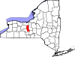

http://www.co.seneca.ny.us/

Steuben County:

http://www.steubencony.org/

Suffolk County:
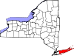

http://www.co.suffolk.ny.us/

County Executive - Environmental Control

Department of Environment and Energy
A. Mission
The mission of the Department of Environment and Energy is to safeguard the natural resources of Suffolk County and to provide a centralized office for consideration of issues and activities from the perspective of their impact on the environment.
- Promote the remediation and redevelopment of Brownfield sites.
- Encourage proper solid waste management.
- Preserve and protect farmlands, parkland, open spaces, and ecological resources (critical, stressed or endangered ecosystems, and species).
- Ensure the acquisition and disposition of interests in real property by Suffolk County in accordance with the highest standards of conduct.
- Coordinate efforts to ascertain any links between the environment and incidents of cancer on Long Island.
- Conserve energy and help achieve sources of energy for county facilities, consumers, and businesses.
- Coordinate the activities of the CEQ (Council on Environmental Quality) with the County Department of Environment and Energy in addition to the County Executive and the County Legislature.
B. Responsibilities
- Advise and assist any department, board, division, or agency of the Suffolk County government, including the County Legislature and Office of the County Executive, on matters pertaining to the environment or energy, except those matters currently handled by the Council on Environmental Quality and the Office of Ecology of the Suffolk County Department of Health Services
- Make recommendations to the County Legislature and County Executive as to what county-owned properties should be dedicated to the County nature preserve, historic trust, conservation of agricultural lands, or bird sanctuary, and what properties not owned by the County should be acquired for purposes such as dedication
- Assist and advise the County Executive in the preparation of the Annual Report on the Environmental Quality of Suffolk County pursuant to Section 1-6 of the SUFFOLK COUNTY CHARTER
- Report to the County Legislature and County Executive on any actions or activities likely to have an impact on the quality of the environment within the County of Suffolk
- On request of the County Legislature or County Executive, review and evaluate any project or activity affecting the quality of the environment of Suffolk County
- Continue to coordinate with the County Department of Economic Development and Workforce Housing in connection with transfers of any interest in real property authorized by Section 72-h of the NEW YORK GENERAL MUNICIPAL LAW

Department of Health Services – Division of Environmental Quality:

The major programs of the Division of Environmental Quality are groundwater and drinking water protection, wastewater management, toxic and hazardous materials pollution control, monitoring and laboratory analyses, enforcement of regulations, and environmental management studies and programs for groundwater and surface waters, including related ecological issues. These programs are managed through the five offices of the division: Water Resources, Pollution Control, Wastewater Management, Ecology, and the Public and Environmental Health Laboratory.

Planning:

Council on Environmental Quality

Environmental Analysis

Information Resources

SC Planning Commission & Regulatory Review

Sullivan County:
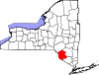
http://www.scgnet.us/
Department of Planning and Environmental Management

Tioga County:
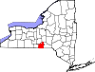
http://www.tiogacountyny.com/

Soil and Water Conservation District

Tompkins County:
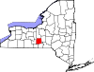

http://www.co.tompkins.ny.us/

Solid Waste Management Division

Ulster County:
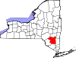

http://www.co.ulster.ny.us/

Warren County:
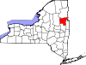

http://www.co.warren.ny.us/

Washington County:
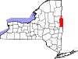

http://www.co.washington.ny.us/

Sewer District

Wayne County:
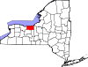

http://www.co.wayne.ny.us/

Westchester County:
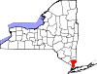

http://www.westchestergov.com/firstvisit.htm

Department of Environmental Facilities

Solid Waste Commision

Wyoming County:
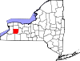

http://www.wyomingco.net/

Yates County:
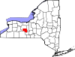

http://www.yatescounty.org/

