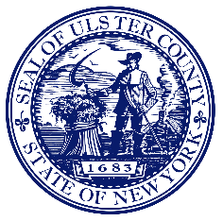
ULSTER COUNTY PURCHASING DEPARTMENT
LIVING WAGE LAW COMPLIANCE
PO BOX 1800
KINGSTON, NY 12402-1800

NOTICE TO EMPLOYEES WAGE REQUIREMENTS

(Living Wage Act – Local Law No. 6 of 2021)

Your employer has a contract with the County of Ulster to provide services to the County. If you provide direct, measurable work under that contract you may be covered by the County’s Living Wage Act, which requires your employer to pay you at least $15.00 per hour, effective January 1, 2022, for each hour you work under that contract. If you think your employer is not paying you the amount required by the Living Wage Act, you have the right to file a confidential complaint.

If you are not sure whether you are covered, or for more information on the Living Wage Act, please call (845) 943-6102 or email:uclivingwagelaw@co.ulster.ny.us

