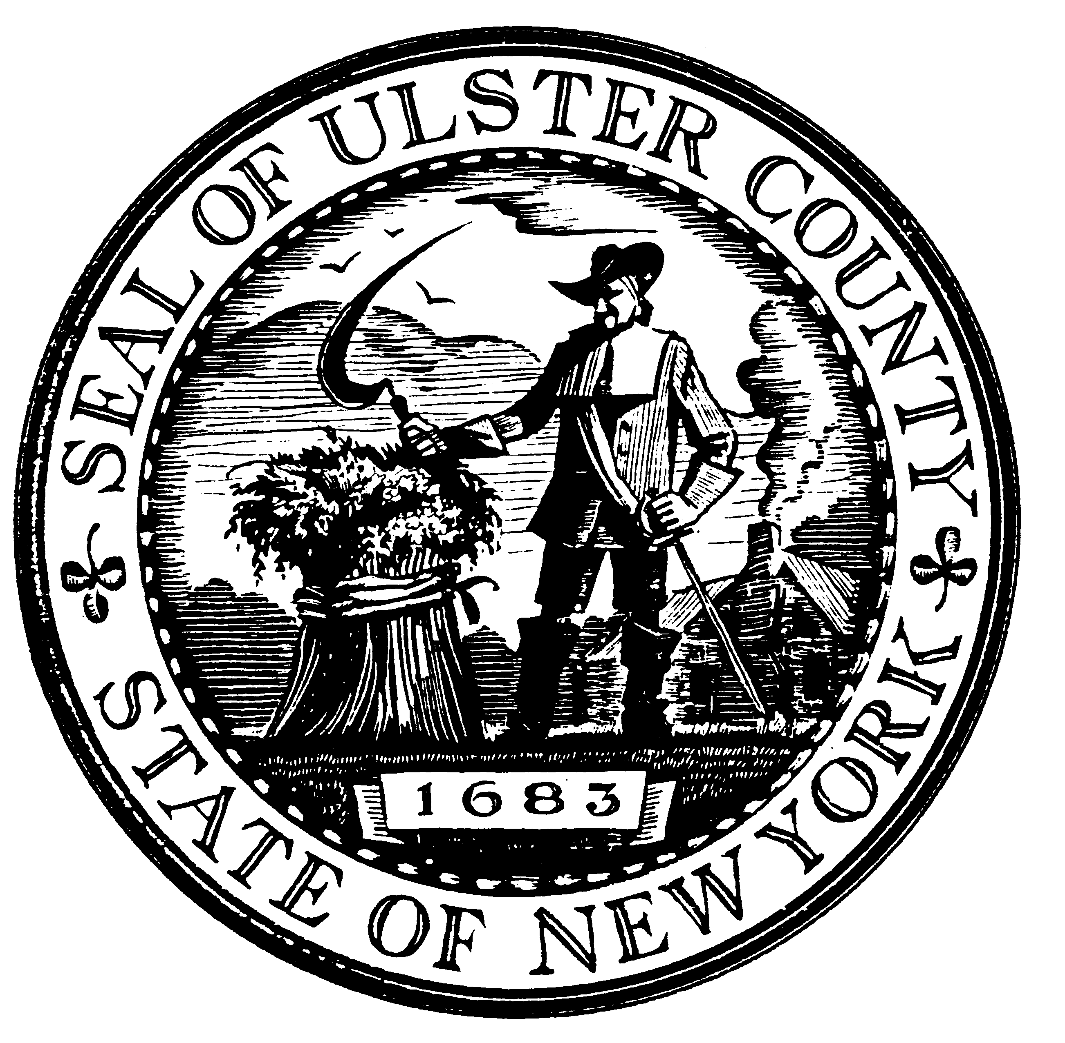

David B. Donaldson
Chairman
Ulster County Legislature

State of the County

Brian Cahill, Majority Leader
Robert Parete, Majority Whip
Glenn Noonan, Minority Leader
Susan Cummings, Minority Whip

Gary Bischoff Richard Parete Robert Aiello Joseph Roberti
Thomas Briggs Jeanette Provenzano Dean Fabiano Kevin Roberts
Frank Dart Hector Rodriguez Frank Fellicello Kenneth Ronk
Jon Decker Brian Shapiro Richard Gerentine Catherine Terrizzi
Donald Gregorius Mary Sheeley Paul Hansut
Peter Kraft Joseph Stoeckeler Wayne Harris
Alan Lomita Philip Terpening James Maloney
Peter Loughran Susan Zimet Laura Petit

January 2, 2008

