TRANSIT PROJECT APPLICATION
Federal Transit Administration (FTA)
Section 5307 Funds
Mid-Hudson Valley
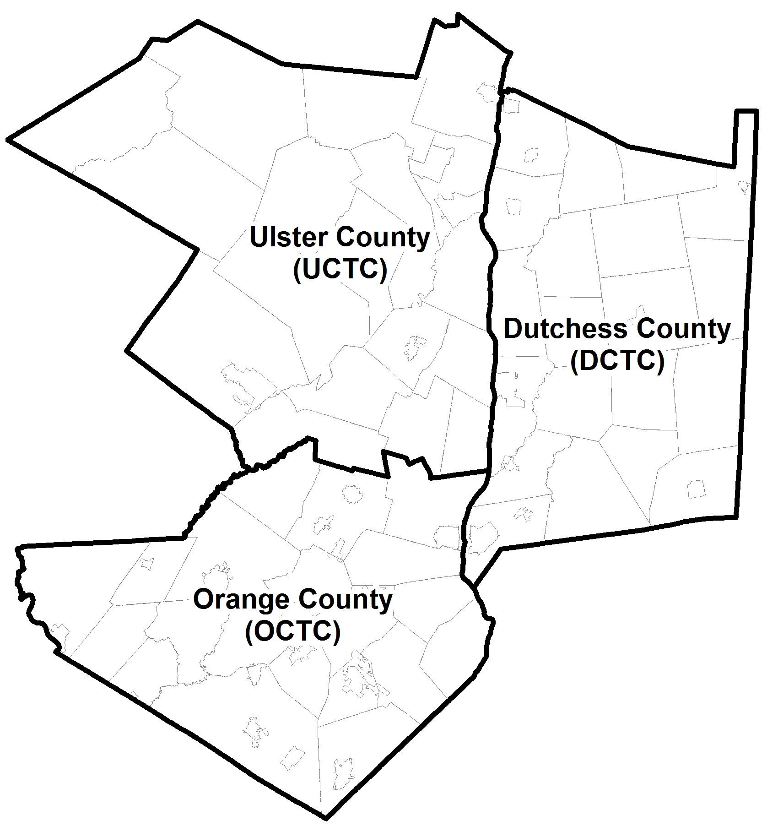
New York Transportation Management Area
For Additional Information or Eligibility Inquiries, Please Contact:
DCTC  Mark Debald  Tel # 845-486-3600  mdebald@dutchessny.gov | OCTC  Julie Richmond  Tel # 845-615-3844  JRichmond@orangecountygov.com | UCTC  Brian Slack  Tel # 845-334-5590  bsla@co.ulster.ny.us
APPLICATION DEADLINE DECMEBER 22, 2017
APPLICATION FORM
Federal Transit Administration Section 5307 Funds
Mid-Hudson Valley, New York Transportation Management Area

1 - PROJECT INFORMATION
Project Name:
Location:
County:

2 - APPLICANT CONTACT INFORMATION
Name:
Title:
Municipality/Organization:
Mailing/Street Address:
City/Town/Village:
Zip Code:
County:
Telephone Number:
Fax Number:
E-Mail Address:

3 - PROJECT SPONSOR (if different from applicant)

4 - PROJECT LEAD AGENCY

5 - ENTITY RESPONSIBLE FOR IMPLEMENTATION AND MAINTENANCE

6 - SIGNATURE OF DESIGNATED RECIPIENT:

7 - APPLICANT/SPONSOR’S SIGNATURE:

8 - | Describe the project:

9 - | Describe the travel market that the project is intended to serve:

10 - | How does the project enhance or expand transit services?

11 - | How does the project enhance connectivity, accessibility, comfort and/or ease of use?

12 - | How does the project support economic and environmental sustainability?

13 - | How does the project improve system safety, security, reliability and maintain a state of good repair?

14 - | How does the project promote or encourage innovative practices or projects that demonstrate the capacity to expand the use of transit to meet regional mobility objectives?

15 - | Describe the benefits derived from the project (include an estimate of the number of daily riders served and the source of the estimate):

16 - | Describe any coordination with other agencies or municipalities in the development of this project:

17 - | Does this project meet the FTA classification of a transit enhancement project?:

18 - | Provide documentation that the NEPA and permitting processes have been completed for the proposed project:

19 - | What is the proposed schedule for the implementation of the project?

20 - | What is the source of operating/maintenance funds for this project after implementation?

PROJECT COSTS AND SCHEDULE

Project Phase | Estimated Cost (in millions) |  |  |  | Date
Construction – (C) | Total Phase Cost: | $ | 0.00 | M
Construction – (C) | 5307 Phase Cost: | $ | 0.00 | M
Construction – (C) | Match Phase Cost: | $ | 0.00 | M
Construction – (C) | Other Phase Cost: | $ | 0.00 | M
Construction Inspection – (I) | Total Phase Cost: | $ | 0.00 | M
Construction Inspection – (I) | 5307 Phase Cost: | $ | 0.00 | M
Construction Inspection – (I) | Match Phase Cost: | $ | 0.00 | M
Construction Inspection – (I) | Other Phase Cost: | $ | 0.00 | M
Miscellaneous – (M) | Total Phase Cost: | $ | 0.00 | M
Miscellaneous – (M) | 5307 Phase Cost: | $ | 0.00 | M
Miscellaneous – (M) | Match Phase Cost: | $ | 0.00 | M
Miscellaneous – (M) | Other Phase Cost: | $ | 0.00 | M
Railroad Force Account – (F) | Total Phase Cost: | $ | 0.00 | M
Railroad Force Account – (F) | 5307 Phase Cost: | $ | 0.00 | M
Railroad Force Account – (F) | Match Phase Cost: | $ | 0.00 | M
Railroad Force Account – (F) | Other Phase Cost: | $ | 0.00 | M
Transit – (T) | Total Phase Cost: | $ | 0.00 | M
Transit – (T) | 5307 Phase Cost: | $ | 0.00 | M
Transit – (T) | Match Phase Cost: | $ | 0.00 | M
Transit – (T) | Other Phase Cost: | $ | 0.00 | M
 | Total | $ | 0.00 | M

Source of other funds:

Detailed program guidance can be found in FTA Circular 9030.1E – URBANIZED AREA FORMULA PROGRAM: PROGRAM GUIDANCE AND APPLICATION INSTRUCTIONS January 16, 2014, available online at https://www.transit.dot.gov/sites/fta.dot.gov/files/docs/FINAL_FTA_circular9030.1E.pdf

