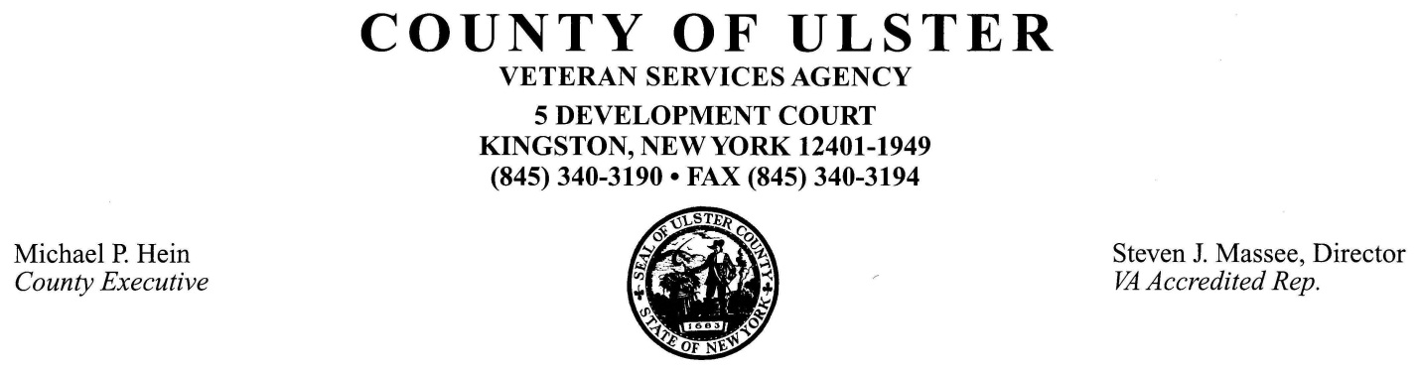
Ulster County Veterans Cemetery (UCVC)
Frequently Asked Questions

- Where is the Ulster County Veterans Cemetery located?
  - 81 Plains Road New Paltz, NY, on the grounds of the New Paltz Rural Cemetery (NPRC).
- Does the County own the UCVC?
  - No. The County contracts with the NPRC to partition a section exclusively designated as the UCVC. Once a veteran is interred there, a plot deed is issued by NPRC in the name of the veteran.
- Who can be buried there?
  - Eligible veterans and optionally, his/her spouse.
  - When a plot is to be reserved for a future spouse burial, an Affidavit of Intent is required.
- How is an “eligible veteran” defined?
  - The veteran must have served in armed forces of the U.S. or National Guard, received no less than a “general” discharge and a resident of Ulster County (see Eligibility Policy).
- What are the costs?
  - Ulster County pays for the cost of the veteran’s burial plot, grave marker footing and interment. Veteran grave markers are ordered from the federal Veterans Administration (VA).
  - Ulster County pays for the cost of the veteran’s spouse burial plot, grave marker footing and interment. Spouse grave markers are ordered and paid for by the burial informant.
  - Cemetery fees are established by NPRC and NYS regulations.
- Can a plot be pre-purchased or reserved?
  - Plots are assigned upon the death of the veteran (or spouse).
  - An adjacent plot for a spouse is reserved (when requested), upon the burial of a spouse.
  - A spouse burial affidavit is required.
- Who makes arrangements for a veteran or spouse burial in UCVC?
  - The funeral home makes the arrangements with NPRC upon request of the next of kin.
  - A Burial Referral/Request Form is required if there is no funeral home involved.
- Are there rules for grave markers?
  - Yes. Only federal flat bronze markers are permitted, installed by NPRC. The federal VA provides markers for most veterans. Spouse markers must be identical to the federal flat bronze style and are purchased by the family from a local supplier.
- Can spouses be interred in the same plot as the veteran?
  - Yes, but only if both are cremated.
- Are VA benefits available for the expenses of a veteran’s funeral?
  - Bronze grave markers are provided by the VA at no cost for all eligible veterans. Other federal burial benefits are available to some veterans that meet certain VA eligibility criteria.
- Can donations be made to the UCVC?
  - Yes. A committee of volunteer veterans oversees and makes improvements to the UCVC from donations and fund raising.
- Who maintains the UCVC?
  - NPRC and the County of Ulster perform routine maintenance and care of the grounds. A volunteer oversight committee reviews improvement plans for the cemetery.
- Are military honors performed at burials at NPRC?
  - Upon request of the family, military honors are performed. Arrangements are made by the funeral home handling the burial.
- Where can I get more information or ask questions?
  - The Ulster County Veteran Services Agency, 5 Development Court, Kingston, NY; 845-340-3190.

